**DNA Sequencing Using** **QiaSeq**

**Targeted DNA Panels**

**Validation / Verification**

**LMH TEST VALIDATION OR VERIFICATION PROTOCOL TEMPLATE**

**INDEX**

INTRODUCTION 3

How to use this template 3

Methods for recording and evaluating results 4

Table 1: Parameters to be determined for different types of test. 6

Abbreviations & Definitions 7

Aims: 7

Reference Documents: SOPs, Instructions, manuals, forms to be used in validation study 7

Equipment Used: 7

Measuring/Testing/Monitoring Equipment 8

SECTION 1: Validation / Verification Details 9

Section 1.1: Test details 9

1.1.1The Myeloid and Lymphoid QiaSeq Targeted DNA Gene Panels 9

The QiaSeq Myeloid Targets 10

The QiaSeq Lymphoid Targets 11

1.1.2: Outline methodology 12

1.1.3: Technical and Bioinformatics Assessment 12

Section 1.2: Validation details 14

1.2.1 Performance Characteristics Acceptance Criteria: 15

SECTION 2. Verification of Utility 16

SECTION 3.0 : Performance metrics (consistent performance - robustness) Validation / Verification 17

3.1 Work plan 17

3.2: Results 18

A Review of NextSeq 550 data output 18

Bioinformatics sequencing depth and coverage analysis 20

3.3 Interpretation 23

3.4 Outcome / limitations 23

SECTION 4.0: Sensitivity, Specificity and Accuracy Validation 23

4.1 Work plan 23

4.2 Results 24

4.2.1 Comparison of TSCA MGP variant detection vs Qiaseq MGP 24

4.2.2 Comparison of TSCA variant detection results vs Qiaseq LGP 25

4.2.3 Bioinformatics technical assessment of sensitivity/specificity 26

4.3: Outcome / limitations 32

4.3: Conclusions 32

SECTION 5.0: Trueness Validation / Verification 33

5.1 Work plan 33

5.2 Results 34

QiaSeq MGP Trueness data using multiple repeats under different run conditions 34

QiaSeq Lymphoid Gene Panel Trueness data using multiple repeats 37

5.3 Interpretation 38

5.4 Outcome / limitations 38

SECTION 6.0: Linearity Validation / Verification 39

6.1 Work plan 39

6.2 Results 40

Technical Bioinformatics Analysis of QiaSeq MGP 42

6.3 Interpretation 43

6.4 Outcome / limitations 43

SECTION 7.0: Repeatability Validation / Verification 44

7.1 Work plan 44

7.2 Results 44

Technical Bioinformatics assessment of repeatability 46

7.3 Interpretation 47

7.4 Outcome / limitations 47

SECTION 8.0 : Intermediate precision Validation / Verification 48

8.1 Work plan 48

8.2 Partial results and conclusions 48

8.3: Interpretation 49

8.4: Outcome / limitations 49

SECTION 9.5 : Reproducibility Validation / Verification 50

9.1 Work plan 50

9.2 Results 51

UKAS AML EQA vs QiaSeq MGP Data 51

CLL EQA vs QiaSeq LGP Data 53

9.3 Interpretation 55

9.4 Outcome / limitations 55

SECTION 10.0 : Limit of Detection/Quantification Validation / Verification 56

10.1 Work plan 56

10.2 Results 57

Technical bioinformatics analysis 57

10.3 Interpretation 63

Operational guidelines and QC thresholds 64

10.4 Outcome / limitations 64

SECTION 11.0 : Measurement Uncertainty Validation / Verification 65

11.1 Work plan 65

11.2 Results 66

11.3: Interpretation 66

11.4: Outcome / limitations 66

SECTION 12. Validation / Verification Final Conclusions 67

Deviations Observed: 67

Changes to the Validation Plan or other documents that may be necessary: 67

Issues / Commentary 67

Revalidation Criteria\Conditions based on validation findings: 67

TEST VALIDATION/VERIFICATION FINAL APPROVAL 69

APPROVAL FOR TEST INTRODUCTION 70

# INTRODUCTION

## How to use this template

1. Section 1 should be completed as far as possible to establish the goals and general format of the validation or verification.
   1. Sections 1.1 “Intended use or application” and 1.2 “Requirements” must be completed at the start of the procedure. The assessment of the validation/verification depends formally on confirmation, through the provision of objective evidence, that these requirements have been fulfilled.
   2. If mentioned (1.2), the “Expected Performance” should be distinguished from the “Requirements”, which must be shown to have been fulfilled.

E.g. The statement “should detect all known point mutations of haemophilia A” could be included as a guide in the Expected performance. If stated as a requirement, however, it would need to be proved.

1. Section 2 covers the validation of utility which should be carried out for all validations and verifications. In the majority of cases this section can be completed on objective evidence from developmental work, design procedures (e.g. SNP checking primers) or by the use of limitations or controls in the on-going test. Where this is not the case, work plans for relevant parameters should be prepared as in 3 below.
2. Appropriate parameters for experimental investigation should be identified with the aid of table 1 – a checklist is also provided at the top of section 3. For each parameter required, the investigating scientist develops a work plan based on section 3 (these are referenced 3.1, 3.2 to 3.n) by completing copies of sections 3.n.1 (‘Aims’, ‘Samples’ and ‘Methodology’). It is suggested that these be maintained in a single document.
3. Note: several parameters may be tested in a single experiment, for example sensitivity and specificity.
4. The work plan[s] should be agreed and authorized by the investigating and the senior scientist by signing and dating in the boxes provided.
5. The experimental work is performed and analysed by the investigating scientist who should then complete the ‘experimental results’ and ‘interpretation’ sections 3.n.2.
6. The ‘outcome and limitations’ should be agreed between the investigating and senior scientists by signing and dating in the boxes provided.
7. Points 3 to 6 should be repeated for each parameter to be tested.
8. If there is any non-compliance between the experimental results and the required performance specification detailed in section 1.2 the parameter in question should to be re-examined to determine if the methodology can be changed or new limitations introduced to rectify the non-compliance. Any further work should be recorded in a new section 3 work plan. Alternatively the implementation can be abandoned.
9. Once all the parameters have been satisfactorily investigated the investigating and senior scientist can agree and sign off the final conclusions in section 4.
10. Assuming the validation / verification has been completed satisfactorily an implementation plan can be drawn up. Appendix B provides a basis for an administrative checklist for the implementation.

## Methods for recording and evaluating results

1. Name all files (e.g. MS Excel workbooks) with sufficient descriptive detail to allow raw data to be indexed and referenced reliably.
2. Make sure there is plenty of space to record all testing results
3. Print all pages up to the “Protocol Authorised By” section as soon as the protocol is finished and get it signed immediately
4. Add text to the results sections and print out as soon as these are complete, adding these pages to the signed protocol.
5. Staple any supplementary pages together to ensure they are not separated or, if there are too many pages to staple, ensure any supplementary pages (e.g. Excel spreadsheets containing raw data) are indexed as numbered Appendices, ensuring each page is numbered
6. File the completed record in a proper records folder.
7. Overwrite the example text with information specific to the process, procedure, equipment or facilities being qualified
8. Don’t forget to delete non-applicable references or content but do not delete non-applicable sections (enter “Not Applicable” and state WHY briefly)

**This Protocol must be completed, printed & signed BEFORE any validation testing begins (i.e. BEFORE any results are added to later pages.**

**A copy may be taken by personnel performing validation, but the original must be retained by the Quality Manager and filed with all other validation documents.**

## Table 1: Parameters to be determined for different types of test.

|  |  |  |  |  |  |  |  |  |  |
| --- | --- | --- | --- | --- | --- | --- | --- | --- | --- |
|  | **Description** | **Examples** | **Sensitivitya** | **Specificityb** | **Accuracyc** | **Trueness** | **Precisiond** | **Limits of detection** | **Probabilitye** |
| **A** | Q**uantitative** tests.  The result can have any value between two limits (including decimals). | Determination of methylation load (%); characterization of a mosaic mutation; heteroplasmy of mitochondrial variants. |  |  |  | **++** | **++** | **++** |  |
| **B** | **Categorical** tests where the quantitative signal is placed into an ordinal series to give the final result. | Sizing a PCR product; determination of triplet repeat size (FRAXA, Huntington disease, etc.) |  |  | **+** | **++** | **++** | **++** | **+** |
| **C** | **Categorical** tests where the quantitative signal is placed into one of a limited series of predefined categories to give the final result. | Determination of copy number using PCR or MLPA.: exon deletion / duplication in *BRCA1*; *PMP22* gene dosage in CMT and HNPP; |  |  | **+** | To establish correction factors and/or cut-offs | |  | **++** |
| **D** | **Qualitative** tests where the true quantitative signal can have one of many possible values, but the required result can only have one of two possible values. | Mutation scanning for unknown mutations e.g. by sequencing or high resolution melt. | **++** | **++** | **+** | To establish correction factors and/or cut-offs | | **++**f |  |
| **E** | **Qualitative [binary]** tests where the true quantitative signal can only have one of two possible values | Genotyping for a specific mutation e.g. *CFTR* Phe508del in cystic fibrosis or *HFE* Cys282Tyr in hemochromatosis. | **++** | **++** | **+** | To establish correction factors and/or cut-offs | | **++** f | **+** |

**Legend Notes**

|  |  |  |  |
| --- | --- | --- | --- |
|  | Metric used for implementation validation | a. | Sensitivity = True Positive / (True Positive + False Negative) |
|  | Metric used for implementation or ongoing validation | b. | Specificity = True Negative / (True Negative + False Positive) |
|  | Metric used for ongoing validation | c. | Accuracy = True Result / (True Result + False Result) |
| **++** | Recommended parameter | d. | Precision should be measured in terms of repeatability and intermediate precision (as well as reproducibility for inter-laboratory validations) |
| **+** | Applicable parameter (less used) | e. | The term ‘probability’ is used to describe situations where a probability that the result is correct can be assigned – primarily in ongoing validation (e.g. competitive hypothesis testing) |
|  |  | f. | Should be used in tests where genotyping of low level variations is required for example mitochondrial DNA |

## Abbreviations & Definitions

|  |  |
| --- | --- |
| **Abbreviation** | **Expansion/definition** |
| MGP | Myeloid Gene Panel |
| LGP | Lymphoid Gene Panel |
| TSCA | TruSeq Custom Amplicon |
| IQC | Internal Quality Control |
| AML | Acute Myeloid Leukemia |
| NGS | Next generation sequencing |
| SOP | Standard Operating Procedure |

Add abbreviations & rows as appropriate

## Aims:

Delete or add text as appropriate

1. To Validate the QiaSeq Custom DNA sequencing technology
2. Validation of assay performance characteristics including:
   1. Technical assessment of robustness and quality metrics
   2. Measurement of assay trueness (accuracy) using EQAs and IQC.
   3. Assessment of sensitivity/specificity/accuracy
   4. Measurement of Linearity and describe LOD/LOQ
   5. Test against NEQAS and other EQA material.
   6. Estimate measurement uncertainty using precision data

## Reference Documents: SOPs, Instructions, manuals, forms to be used in validation study

1. [CH-Q-PR-12: Validation Policy/Master Plan (Clinical Haematology)]
2. [GL-GEN-024: ISO 15189:2012 Standards for Medical laboratories
3. UKAS publication M 3003 The Expression of Uncertainty and Confidence in Measurement Edition 1, December 1997.
4. Measurement Good Practice Guide No. 11 (Issue 2). A Beginner’s Guide to Uncertainty of Measurement. Stephanie Bell. Centre for Basic, Thermal and Length Metrology. National Physical Laboratory
5. Illumina NextSeq 550 System Specification Sheet
6. QiaSeq Custom Amplicon reference guide 15027983-02
7. Laboratory SOP: DNA Sequencing using QiaSeq Targeted DNA Panels.
8. Snappy NGS Analysis SOP: LP-HAE-LMH082

## Equipment Used:

List all of the main equipment used in the test procedure

|  |  |  |  |  |
| --- | --- | --- | --- | --- |
| **Manufacturer** | **Model** | **Asset No** | **Serial No** | **Room** |
| Illumina | NextSeq 550 | LMH-xxxx | Nxxxxx | G.19 |
| Hamilton | MicroLab Star | LMH-xxxx | xxxxxx | G.22 |

Add or delete rows as appropriate

## Measuring/Testing/Monitoring Equipment

List all supplementary equipment used to calibrate equipment that forms part of the test procedure or that is used to perform any measurements that form part of this validation study (e.g. temperature data loggers). If this has been performed by a supplier, reference the supplier’s calibration report.

|  |  |  |
| --- | --- | --- |
| **Equipment Type** | **Serial/ID no** | **Calibration Status & Date** |
| n/a |  |  |

Append copies of calibration certificates to the completed protocol or reference the appropriate QPulse Asset record where they may be found.

# SECTION 1: Validation / Verification Details

## Section 1.1: Test details

## 1.1.1The Myeloid and Lymphoid QiaSeq Targeted DNA Gene Panels

Background: targeted DNA re-sequencing panels use next-generation sequencing (NGS) technology to identify somatic or acquired mutations in patient material. Here, we designed panels to sequence genes or gene sub-regions (hot spots) that are frequently mutated in acute myeloid leukemia (AML), myelodysplastic syndrome (MDS) and myeloproliferative neoplasms (MPN) as well as lymphoid diseases. The assay is not strictly limited to these exact designs however, as it is routine to add or remove gene targets as and when required by the NHSE test directory or suggested by clinical need. For the purposes of this validation, genes panels targeting myeloid and lymphoid genes will be used as examples to validate the technology. If genes are added or removed, it will be necessary to perform only a restricted verification to ensure all quality metrics pass acceptance criteria for any changes made.

Requirements of the assay: This method is designed to detect somatic and inherited mutations in clinically relevant sample, for example peripheral blood or bone marrow. These samples may be for the purpose of diagnosis and/or prognosis, and very occasionally for continued monitoring purposes, if deemed necessary by a clinician.

It must be noted that there is as yet no national framework concerning results metrics and analysis of targeted resequencing NGS data, in particular in somatic disease. Some recommendations have been published or are under discussion by NHSE, but these provide no definitive methods of guidelines. Therefore, we have undertaken a rigorous approach to validation, including method comparisons and IQC/EQA analysis as well as an in-depth analysis of run metrics and performance.

For the purposes of this validation, we use the Qiagen QiaSeq method (subsequently referred to simply as QiaSeq) to analyse the following myeloid and lymphoid gene targets listed below. The QiaSeq method will be compared to our current UKAS ISO15189-accredited Myeloid Gene Panel, which uses the TruSeq Custom Amplicon method from Illumina (subsequently referred to as TSCA) as well as EQA materials. The majority of assessment of technical performance will be carried out using the myeloid data as a representative sample. By necessity at this stage, there are fewer lymphoid control samples available, as this is a new requirement. Therefore a smaller data set will be presented for the QiaSeq LGP compared to the QiaSeq MGP. However, given the identical assay methodology, we expect there to be little or no difference in performance and we will continue to monitor this as an ongoing part of the validation.

## The QiaSeq Myeloid Targets

|  |  |  |  |
| --- | --- | --- | --- |
| Gene | Chr | Targets | Transcript |
| ANKRD26 | chr10 | all coding | [NM_014915.3](https://varsome.com/transcript/hg19/NM_014915.3) |
| ASXL1 | chr20 | 12 | [NM_015338.6](https://www.ncbi.nlm.nih.gov/nuccore/NM_015338.6) |
| BCOR | chrX | all coding | [NM_001123385.2](https://varsome.com/transcript/hg19/NM_001123385.2) |
| CALR | chr19 | 9 | [NM_004343.4](https://varsome.com/transcript/hg19/NM_004343.4) |
| CBL | chr11 | 7 + 8 + 9 | [NM_005188.4](https://varsome.com/transcript/hg19/NM_005188.4) |
| CEBPA | chr19 | all coding | [NM_004364.4](https://varsome.com/transcript/hg19/NM_004364.4) |
| CHEK2 | chr22 | all coding | [NM_001005735.2](https://varsome.com/transcript/hg19/NM_001005735.2) |
| CSF3R | chr1 | 13 - 18 | [NM_156039.3](https://varsome.com/transcript/hg19/NM_156039.3) |
| CUX1 | chr7 | all coding | [NM_181552.4](https://varsome.com/transcript/hg19/NM_181552.4) |
| DDX41 | chr5 | all coding | [NM_016222.4](https://varsome.com/transcript/hg19/NM_016222.4) |
| DNMT3A | chr2 | all coding | [NM_022552.4](https://varsome.com/transcript/hg19/NM_022552.4) |
| ETV6 | chr12 | all coding | [NM_001987.5](https://varsome.com/transcript/hg19/NM_001987.5) |
| EZH2 | chr7 | all coding | [NM_004456.5](https://varsome.com/transcript/hg19/NM_004456.5) |
| FLT3 | chr13 | 14 + 15 + 20 | [NM_004119.3](https://varsome.com/transcript/hg19/NM_004119.3) |
| GATA1 | chrX | all coding | [NM_002049.4](https://varsome.com/transcript/hg19/NM_002049.4) |
| GATA2 | chr3 | all coding | [NM_032638.5](https://varsome.com/transcript/hg19/NM_032638.5) |
| HRAS | chr11 | 2 + 3 | [NM_001130442.2](https://varsome.com/transcript/hg19/NM_001130442.2) |
| IDH1 | chr2 | 4 | [NM_005896.3](https://varsome.com/transcript/hg19/NM_005896.3) |
| IDH2 | chr15 | 4 | [NM_002168.4](https://varsome.com/transcript/hg19/NM_002168.4) |
| IKZF1 | chr7 | all coding | [NM_006060.6](https://varsome.com/transcript/hg19/NM_006060.6) |
| JAK2 | chr9 | 12 + 14 | [NM_004972.4](https://varsome.com/transcript/hg19/NM_004972.4) |
| KIT | chr4 | 2, 8-11, 13 + 17 | [NM_000222.3](https://varsome.com/transcript/hg19/NM_000222.3) |
| KMT2A | chr11 | all coding | [NM_001197104.2](https://varsome.com/transcript/hg19/NM_001197104.2) |
| KRAS | chr12 | 2 + 3 | [NM_033360.4](https://varsome.com/transcript/hg19/NM_033360.4) |
| MPL | chr1 | 10 | [NM_005373.3](https://varsome.com/transcript/hg19/NM_005373.3) |
| NF1 | chr17 | all coding | [NM_001042492.3](https://varsome.com/transcript/hg19/NM_001042492.3) |
| NFE2 | chr12 | all coding | [NM_001136023.3](https://varsome.com/transcript/hg19/NM_001136023.3) |
| NPM1 | chr5 | 12 | [NM_002520.6](https://varsome.com/transcript/hg19/NM_002520.6) |
| NRAS | chr1 | 2 + 3 | [NM_002524.5](https://varsome.com/transcript/hg19/NM_002524.5) |
| PHF6 | chrX | all coding | [NM_032458.3](https://varsome.com/transcript/hg19/NM_032458.3) |
| PPM1D | chr17 | all coding | [NM_003620.4](https://varsome.com/transcript/hg19/NM_003620.4) |
| PTPN11 | chr12 | 3 + 13 | [NM_002834.5](https://varsome.com/transcript/hg19/NM_002834.5) |
| RAD21 | chr8 | all coding | [NM_006265.3](https://varsome.com/transcript/hg19/NM_006265.3) |
| RUNX1 | chr21 | all coding | [NM_001754.4](https://varsome.com/transcript/hg19/NM_001754.4) |
| SETBP1 | chr18 | 4 | [NM_015559.3](https://varsome.com/transcript/hg19/NM_015559.3) |
| SF3B1 | chr2 | 12 - 16 | [NM_012433.4](https://varsome.com/transcript/hg19/NM_012433.4) |
| SH2B3 | chr12 | all coding | [NM_005475.3](https://varsome.com/transcript/hg19/NM_005475.3) |
| SRSF2 | chr17 | 1 | [NM_003016.4](https://varsome.com/transcript/hg19/NM_003016.4) |
| STAG2 | chrX | all coding | [NM_001042749.2](https://varsome.com/transcript/hg19/NM_001042749.2) |
| TET2 | chr4 | all coding | [NM_001127208.2](https://varsome.com/transcript/hg19/NM_001127208.2) |
| TP53 | chr17 | all coding | [NM_000546.5](https://varsome.com/transcript/hg19/NM_000546.5) |
| U2AF1 | chr21 | 2 + 6 | [NM_006758.2](https://varsome.com/transcript/hg19/NM_006758.2) |
| WT1 | chr11 | 7 + 9 | [NM_024426.6](https://varsome.com/transcript/hg19/NM_024426.6) |
| ZRSR2 | chrX | all coding | [NM_005089.3](https://varsome.com/transcript/hg19/NM_005089.3) |

## The QiaSeq Lymphoid Targets

|  |  |  |  |  |
| --- | --- | --- | --- | --- |
| Gene | Chr | Targets | Transcript | Alt transcript |
| ARAF | chrX | all coding | [NM_001654.5](https://www.ncbi.nlm.nih.gov/entrez/query.fcgi?cmd=Search&db=Nucleotide&term=NM_001654&doptcmdl=GenBank&tool=genome.ucsc.edu) | [NM_001256196.1](https://varsome.com/transcript/hg19/NM_001256196.1) |
| ARID1A | chr1 | all coding | [NM_006015.6](https://varsome.com/transcript/hg19/NM_006015.6) |  |
| BRAF | chr7 | exon 15 | [NM_004333.6](https://varsome.com/transcript/hg19/NM_004333.6) |  |
| BTK | chrX | all coding | [NM_000061.3](https://varsome.com/transcript/hg19/NM_000061.3) |  |
| CARD11 | chr7 | all coding | [NM_032415.6](https://varsome.com/transcript/hg19/NM_032415.6) |  |
| CREBBP | chr16 | all coding | [NM_004380.3](https://varsome.com/transcript/hg19/NM_004380.3) |  |
| CXCR4 | chr2 | all coding | [NM_003467.3](https://varsome.com/transcript/hg19/NM_003467.3) |  |
| DIS3 | chr13 | all coding | [NM_014953.5](https://www.ncbi.nlm.nih.gov/nuccore/NM_014953.5) |  |
| DNMT3A | chr2 | all coding | [NM_022552.4](https://varsome.com/transcript/hg19/NM_022552.4) |  |
| EP300 | chr22 | all coding | [NM_001429.4](https://www.ncbi.nlm.nih.gov/nuccore/NM_001429.4) |  |
| ERBB3 | chr12 | all coding | [NM_001982.4](https://www.ncbi.nlm.nih.gov/nuccore/NM_001982.4) |  |
| ETV6 | chr12 | all coding | [NM_001987.5](https://varsome.com/transcript/hg19/NM_001987.5) |  |
| EZH2 | chr7 | all coding | [NM_004456.5](https://varsome.com/transcript/hg19/NM_004456.5) |  |
| TENT5C | chr1 | all coding | [NM_017709.4](https://www.ncbi.nlm.nih.gov/entrez/query.fcgi?cmd=Search&db=Nucleotide&term=NM_017709&doptcmdl=GenBank&tool=genome.ucsc.edu) |  |
| FBXW7 | chr4 | all coding | [NM_033632.3](https://varsome.com/transcript/hg19/NM_033632.3) | [NM_001349798.2](https://www.ncbi.nlm.nih.gov/nuccore/NM_001349798.2) |
| FOXO1 | chr13 | all coding | [NM_002015.4](https://www.ncbi.nlm.nih.gov/nuccore/NM_002015.4) |  |
| HRAS | chr11 | 2 + 3 | [NM_005343.4](https://www.ncbi.nlm.nih.gov/nuccore/NM_005343.4) | [NM_001130442.2](https://varsome.com/transcript/hg19/NM_001130442.2) |
| IDH2 | chr15 | exon 4 | [NM_002168.4](https://www.ncbi.nlm.nih.gov/nuccore/NM_002168.4) |  |
| IRF4 | chr6 | all coding | [NM_002460.4](https://www.ncbi.nlm.nih.gov/nuccore/NM_002460.4) |  |
| KRAS | chr12 | 2 + 3 | [NM_033360.4](https://www.ncbi.nlm.nih.gov/nuccore/NM_033360.4) |  |
| MAP2K1 | chr15 | all coding | [NM_002755.4](https://varsome.com/transcript/hg19/NM_002755.4) |  |
| MAP3K1 | chr5 | all coding | [NM_005921.2](https://varsome.com/transcript/hg19/NM_005921.2) |  |
| MEF2B | chr19 | all coding | [NM_001145785.2](https://varsome.com/transcript/hg19/NM_001145785.2) |  |
| MYD88 | chr3 | exons 3 + 4 + 5 | [NM_001172567.2](https://varsome.com/transcript/hg19/NM_001172567.2) | [NM_002468.5](https://varsome.com/transcript/hg19/NM_002468.5) |
| NOTCH1 | chr9 | exon 34 | [NM_017617.5](https://varsome.com/transcript/hg19/NM_017617.5) |  |
| NRAS | chr1 | 2 + 3 | [NM_002524.5](https://varsome.com/transcript/hg19/NM_002524.5) |  |
| PIK3CA | chr3 | all coding | [NM_006218.4](https://varsome.com/transcript/hg19/NM_006218.4) |  |
| PIK3CD | chr1 | 9 | [NM_005026.5](https://varsome.com/transcript/hg19/NM_005026.5) |  |
| PLCG2 | chr16 | all coding | [NM_002661.5](https://varsome.com/transcript/hg19/NM_002661.5) |  |
| RHOA | chr3 | all coding | [NM_001664.4](https://varsome.com/transcript/hg19/NM_001664.4) |  |
| STAT3 | chr17 | exon 20 + 21 | [NM_139276.3](https://www.ncbi.nlm.nih.gov/nuccore/NM_139276.3) |  |
| STAT5B | chr17 | exons 14 + 15 + 16 | [NM_012448.4](https://www.ncbi.nlm.nih.gov/nuccore/NM_012448.4) |  |
| TET2 | chr4 | all coding | [NM_001127208.2](https://varsome.com/transcript/hg19/NM_001127208.2) |  |
| TP53 | chr17 | all coding | [NM_000546.5](https://varsome.com/transcript/hg19/NM_000546.5) |  |

## 1.1.2: Outline methodology

DNA from PB, BM and blood films can be used. The DNA samples will be sequenced using the QiaSeq DNA Custom workflow. We have designed two panels to target 44 genes/gene mutation hotspots known to be involved in myeloid malignancies and 34 genes/gene mutation hotspots for the lymphoid panel.

DNA is quantified and diluted to 10 ng/µl. The DNA libraries are prepared according to the QiaSeq method, using the Hamilton MicroLab Star liquid handling robot. This is followed by quantification and pooling of samples and loading onto an Illumina NextSeq 500 instrument. Fastq files are generated, which are then loaded into a bioinformatics pipeline known as Snappy (see documents XXXXX) followed by variant calling and analysis in SQVD and VASA (see documents XXXX). These pipelines and software have been independently validated. An overview is given below.

## 1.1.3: Technical and Bioinformatics Assessment

**Assay overview**

This report concerns the validation of the Myeloid and Lymphoid QiaSeq NGS panels and associated Snappy data analysis pipeline for targeted small variant detection in key genes/regions associated with Myeloid and Lymphoid neoplasms and associated disorders.

The design of the Qiaseq assay was based on a region of interest set of coordinates (ROI.bed file), corresponding to assay coverage requirements determined by the National test directory and local clinical requirements, and is detailed in relevant laboratory sections of this report. From this, primers were designed to amplify across such regions using Qiaseq methodology, for generation of NGS data (fastq) on Illumina sequencing machines. Only variants falling within this ROI are used in this validation report. For this assay, the Illumina NextSeq 550 machine was employed to generate fastq sequencing data, which in turn is the input for Snappy and SQVD software in genetic variant analysis and annotation/reporting respectively. Qiaseq NGS library preparation was performed via the LMH Hamilton automation system in all cases.

**Qiaseq chemistry molecular barcoding**

The Qiaseq chemistry is based on an initial single primer linear extension of target DNA with unique molecular ‘barcode’ tagging, which can be performed on both intact genomic DNA or DNA extracted from FFPE (formalin-fixed, paraffin-embedded) tissue biopsies. Furthermore, molecular bar-coding allows for constructive use of PCR duplicates arising during the library prep amplification, which are usually removed as potential sources of bias and artefacts, in a process of combining these molecules based on matching parental barcodes, to produce higher-quality ‘consensus’ reads. Combining molecular bar-coding with high sequencing depth, to generate multiple duplicates of the same originating molecule, can be used to increase sequencing sensitivity by removal of artifactual noise. Here, variant base calls not supported in sister molecules (molecular duplicates of originating genomic DNA copies) and are effectively filtered out as processing artefacts.

**Bioinformatic analysis overview and aims**

Validation of the Qiaseq NGS assay here includes validation of the associated bioinformatic pipeline. For this, we are using the ‘Snappy’ pipeline to produce results for targeted variant detection and supporting data QC metrics. Through subsequent validation meta-analyses, we aim to generate key assay performance measures/thresholds and outline the requirements to meet these, with alignment to the defined assay evaluation and acceptance criteria. In particular, we will test the sensitivity, specificity and accuracy of the assay in the detection and quantification of known variants from selected standards and clinical sample sets.

**Snappy QiaSeq pipeline background**

Prior to starting this validation work we had developed the Snappy pipeline, a next generation sequencing (NGS) genetic variant detection software suite. Snappy has previously been validated for analysing both germline variants and cancer associated somatic mutations in red cell disease (clinically relevant cancer panel and the red cell gene panel). The Snappy framework is an extended Python/Ruffus workflow engine. It simultaneously processes batched samples corresponding to one sequencing run or fastq files selected from different sequencing runs. VCF files are outputted and processed for importing into the SQVD variant annotation database. Snappy and SQVD analysis is currently based around Human genome build GRCh37 but has functionality to use genome build HG38 as this becomes the default across NHS England. This validation is completed in build GRCh37.

This validation analysis uses the ‘somatic.Qiaseq’ pipeline and Myeloid configuration, where many of the pipeline components are applied in other Snappy pipelines and have been validated previously. Snappy is already used to deliver the ISO15189 accredited tests within Viapath LLP, the clinically relevant cancer panel and the red cell gene panel. The pipeline uses the following software: Trimmomatic and Cutadapt for adapter trimming; FastQC for read quality assessment; BWA-MEM for read alignment; UMI tools and FBO-bio for generating consensus reads from molecular duplicates; VarDict for variant calling (functionality for GATK4 MuTect is also built into the pipeline, but is not validated here); and BcfTools for variant filtering. QC metrics, including coverage, are calculated with Picard Tools, BcfTools and Bedtools. See <https://git.kingspm.uk> for details and versioning. Snappy version 4 was used here.

**Snappy configuration and validation tools**

The Snappy pipeline has the same internally customizable options as if running any of the tools that it comprises as stand-alone modules. The Snappy somatic.Qiaseq pipeline was run with mainly fixed internal software configurations tailored to the assay during pilot runs and having being validated previously for many components (see Snappy NGS Analysis SOP and associated validation documents).

Snappy was run with set pipeline parameters as specified in its version-controlled repository (/git.kingspm/snappy – snappy V4 branch). Myeloid analysis was selected in the pipeline, which is a derivation of the parent Somatic-Qiaseq pipeline. The configurable options for variant filtration (variant allele frequency [VAF] and variant supporting reads [VD]) were set at a baseline of 0.03 VAF (3%) and 6 supporting reads as standard, but adjusted for limit of detection (LOD) and related assays as required (specified within this report).

Validation bioinformatics was primarily a meta-analysis of QC and variant data coming out of the Snappy pipeline unless otherwise stated. Bioinformatic software tools used in validation were BCFtools, Tabix, Bedtools and Samtools, and were version-aligned to those in the Snappy pipeline. Additionally, the Seqtk software, which is not used by Snappy currently, was used here to sub-sample raw fastq data were applicable. Data manipulation and plotting was performed using common R packages, and core linux data processing utilities.

## Section 1.2: Validation details

|  |  |
| --- | --- |
| **Overall Aims** | To validate the performance of the QiaSeq Custom DNA Gene Panel assay.  In several sections, data is presented both from analysis carried out by the validating Clinical Scientist as well as from technical analysis carried out by the LMH Bioinformatician. This is an important “double check” in this validation and adds a great deal of value, in particular the technical bioinformatics analysis ensures there is no undue bias in results handling. |
| **Validation / Verification** | This is a retrospective validation of the QiaSeq method. |
| **Type** | This test is a method for scanning for sequence mutations, i.e., qualitative, which is derived from quantitative data that meet the criteria in Table 1 for a Type D test. Mutations may also be reported qualitatively, therefor this validation will also test all aspects required of a quantitative assay (Type A). This validation protocol uses sample data, EQA, IQC and quality metrics. In addition, these parameters and control samples will be monitored for ongoing verification. |
| **Scope / limitations** | This test is ideally suited to discovering somatic mutations. This method of amplicon-based NGS is not designed to identify copy number variations or large insertions/deletions (>100bp), therefore large indel detection will not be formally tested here.  This validation is designed to assess panel performance based on run quality. It is impossible, and not appropriate, to validate each gene individually, other than to demonstrate that the gene can be sequenced at adequate depth, without seeing noise or background variants appearing, which cannot be explained as artefactual. Since we have some genes where no mutations have been found (exactly as is the case for obtaining wild-type results in traditional Sanger sequencing), it is reasonable to validate performance based on overall run metrics. Where mutations have been found, the allele burden will be used to assess both qualitative and quantitative data metrics. |
| **Other considerations** | At the time of this validation, sample type is limited to PB and BM in EDTA or Heparin and DNA obtained from bone marrow slides. Further validations to use FF/FFPE will be appended when available. |

## 1.2.1 Performance Characteristics Acceptance Criteria:

Describe the critical functional aspects that must be tested and the criteria for acceptance.

Choose the characteristics applicable to the test type only.

If desired characteristics cannot be specified or calculated from clinical requirements or published guidance consider using information from any EQA schemes (e.g. characteristics observed for the best in class method or overall mean performance.

**Any chosen performance characteristics MUST be set BEFORE testing begins and must be copied into the appropriate results and conclusions sections so that the validation/verification records show how well these were met**. If it is not possible to do this before the work plan is approved and executed, explain why (e.g. no published data).

|  |  |
| --- | --- |
| **Critical Function** | **Acceptance Criteria** |
| Technical assessment of performance and robustness using appropriate quality metrics | The quality metrics generated for a series of samples should show good coverage, with consistent primer performance between runs and samples. As part of this assessment, the vertical coverage (sequencing depth) and the horizontal coverage of the regions of interest (ROI) will be examined. |
| Detection specificity and sensitivity | Where qualitative data is available from another ISO15189-accredited assay, on the same samples, or a standard from a commercial source, we expect ≥95 % sensitivity and specificity. |
| Trueness | Where quantitative data is available from a standard, such as a commercial source, a high level of trueness must be evident, as given by either r2 correlation (≥0.9) or Bland-Altman analysis. |
| Linearity | Where quantitative data is available, a high level of linearity must be evident, as given by r2 correlation (≥0.9). Aspects of this may be used, if possible, to define limit of detection (LOD) and/or limit of quantitation (LOQ). |
| Repeatability/ intra-assay precision | If available, intra-assay repeat samples should be analysed for both presence/absence calls as well as quantitative correlation. Measurement Uncertainty calculations should be performed using this data. |
| Intermediate/ inter-assay precision | If available, inter-assay repeat samples should be analysed for both presence/absence calls as well as quantitative correlation. Measurement Uncertainty calculations should be performed using this data. |
| Reproducibility | A cross-comparison between different methodologies and NEQAS or other EQA samples, should show a high level of reproducibility. This data may be inferred using Trueness and Linearity data where appropriate. |
| LOD/LOQ | Our requirement is to detect a clone size of ≥5%, therefore the read depth required to achieve this will be determined: demonstrate LOD performance (analytical sensitivity) down to at least 5% VAF and provide operational guidelines for the level of sequence coverage required for variant detection down to this level. |
| Measurement Uncertainty | This will be calculated based the precision data. |
| NextSeq 550 Run Performance | Sequencing metrics obtained from the NextSeq instrument should be within the performance specifications of the manufacturer. This data is presented in the NextSeq Instrument Validation document, but will be summarised here. |

# SECTION 2. Verification of Utility

|  |  |
| --- | --- |
| Applicability of measurements | This targeted DNA re-sequencing method uses next-generation sequencing (NGS) technology to identify somatic mutations in malignancies. Panels are designed to sequence genes or gene sub-regions (hot spots) that are frequently mutated in various malignancies. The panels therefore provides a comprehensive assessment of the key genes involved, but in a single test.  The mutation data is used by clinicians both as a diagnostic tool and, where evidence exists, as a prognostic tool. This methodology, in its current form, is not intended as a post-treatment minimal disease monitoring tool, since below around 4% mutation burden, non-specific background mutations become evident. |
| Selectivity | The assay is designed to amplify very specific gene regions. By virtue of the probe design and bioinformatics genome alignment tools, this assay is essentially 100% selective. |
| Interferences | The use of quality metrics generated for each sample and for the run as a whole is an effective way of controlling for variable factors which may adversely affect, or interfere with, assay performance. If unknown/known factors have a detrimental impact on the assay, this will be reflected in coverage, Q30 and other performance metrics. |
| Cross-reactivity | The assay is designed to amplify very specific gene regions. By virtue of the probe design and bioinformatics workflow, cross-reactivity is not a confounding factor. |

# SECTION 3.0 : Performance metrics (consistent performance - robustness) Validation / Verification

We assessed instrument data output and sequence read output per target primer to demonstrate reagent set performance and provision of reproducible sequence data across the target region design.

## 3.1 Work plan

|  |  |
| --- | --- |
| **Section aims** | 1) To demonstrate that the libraries can be sequenced on the NextSeq 550 to give the correct indexing and general performance metrics.  2) To Assess general run metrics, such as vertical coverage (sequencing depth), the horizontal coverage of the regions of interest (ROI) and primer performance using both mid- or high-output kits.  3) Given the above considerations, all samples must meet certain quality thresholds, so these are controlled as part of the workflow. |
| **Samples** | Routine samples and IQCs/EQAs will be used. |
| **Methodology** | Performance of the QiaSeq method will be assessed using NextSeq550 run quality metrics and coverage metrics as determined by bioinformatics analysis. |

## 3.2: Results

## A Review of NextSeq 550 data output

**A summary graphics output from the NextSeq 550 QiaSeq MGP EQA run**

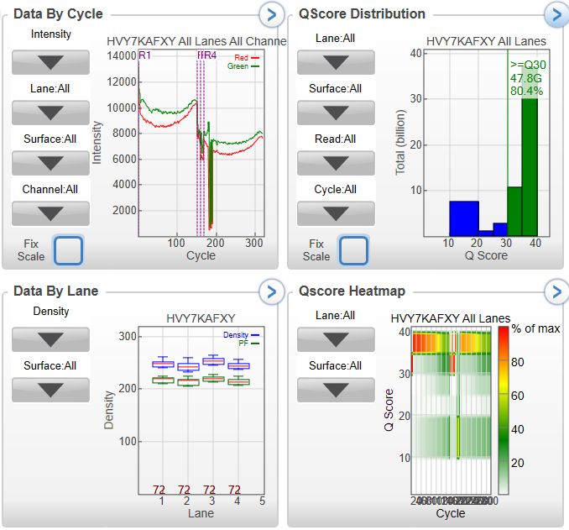

These instrument and library performance metrics show good cluster density and Q score and fall within the performance parameters specified by Illumina for instrument performance (see NextSeq 550 Validation report).

**Sample Indexing/De-multiplexing performance of the NextSeq 500 QiaSeq MGP EQA run**

|  |  |  |  |  |  |
| --- | --- | --- | --- | --- | --- |
| Total Reads | PF Reads | % Reads Identified (PF) | CV | Min | Max |
| 214346071 | 187583118 | 87.0993 | 0.1603 | 2.7593 | 5.0084 |
|  |  |  |  |  |  |
| Index Number | Sample ID | Project | Index 1 (I7) | Index 2 (I5) | % Reads Identified (PF) |
| 1 | 1337979 | NA | TAAGGCGA | ATAGAGAG | 2.7593 |
| 2 | 1339961 | NA | CGTACTAG | ATAGAGAG | 3.7591 |
| 3 | AML_GP103 | NA | AGGCAGAA | ATAGAGAG | 4.0965 |
| 4 | 1339509 | NA | TAAGGCGA | AGAGGATA | 3.4028 |
| 5 | 1337706 | NA | CGTACTAG | AGAGGATA | 3.1377 |
| 6 | AML_GP100 | NA | AGGCAGAA | AGAGGATA | 4.462 |
| 7 | 1339557 | NA | TAAGGCGA | CTCCTTAC | 2.8635 |
| 8 | 1337758 | NA | CGTACTAG | CTCCTTAC | 3.5537 |
| 9 | AML_GP104 | NA | AGGCAGAA | CTCCTTAC | 3.675 |
| 10 | 1339612 | NA | TAAGGCGA | TATGCAGT | 3.0818 |
| 11 | 1337770 | NA | CGTACTAG | TATGCAGT | 3.493 |
| 12 | AML_GP105 | NA | AGGCAGAA | TATGCAGT | 3.9968 |
| 13 | 1339779 | NA | TCCTGAGC | TACTCCTT | 3.171 |
| 14 | 1337901 | NA | GGACTCCT | TACTCCTT | 3.053 |
| 15 | AML_GP106 | NA | TAGGCATG | TACTCCTT | 3.6932 |
| 16 | 1339843 | NA | TCCTGAGC | AGGCTTAG | 4.4248 |
| 17 | 1337903 | NA | GGACTCCT | AGGCTTAG | 3.3797 |
| 18 | AML_GP107 | NA | TAGGCATG | AGGCTTAG | 4.7109 |
| 19 | 1339879 | NA | TCCTGAGC | ATTAGACG | 3.5727 |
| 20 | 1337940 | NA | GGACTCCT | ATTAGACG | 3.0999 |
| 21 | EQA_192001 | NA | TAGGCATG | ATTAGACG | 3.5885 |
| 22 | 1339957 | NA | TCCTGAGC | CGGAGAGA | 3.2863 |
| 23 | AML_GP102 | NA | GGACTCCT | CGGAGAGA | 3.8296 |
| 24 | EQA_192002 | NA | TAGGCATG | CGGAGAGA | 5.0084 |

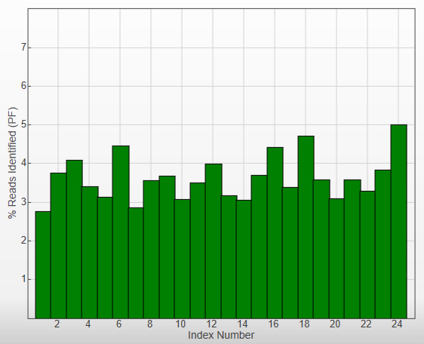

Conclusion: this demonstrates that the NextSeq 550 is able to sequence samples and correctly identify/index them.

## Bioinformatics report: Sample QC summary

Myleiod V2 Qiaseq panel validation experiments and summary Snappy (NGS) QC metrics. All patient sample control samples experiments are shown. EQA samples are those prefixed with either ‘AML’ or ‘EQA’ . Horizon control sample (HC829) is prefixed with HC. HC dilution experiments are also included (dilution indicted in sample experiment name) and represent HC829 diluted with HC752 (wild-type for specified HC829 mutations).

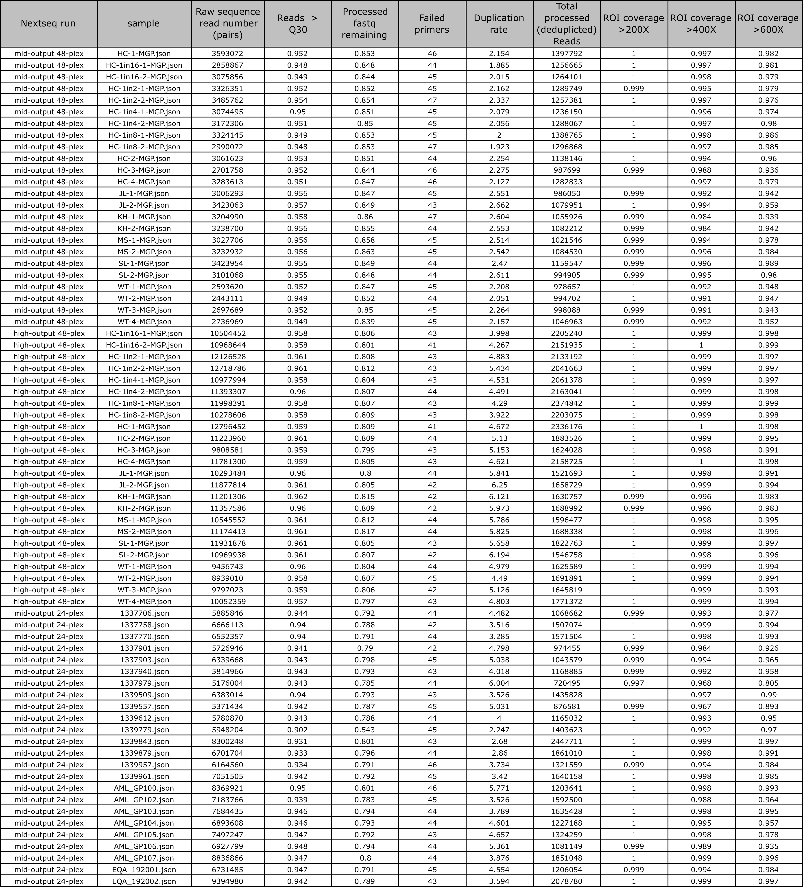

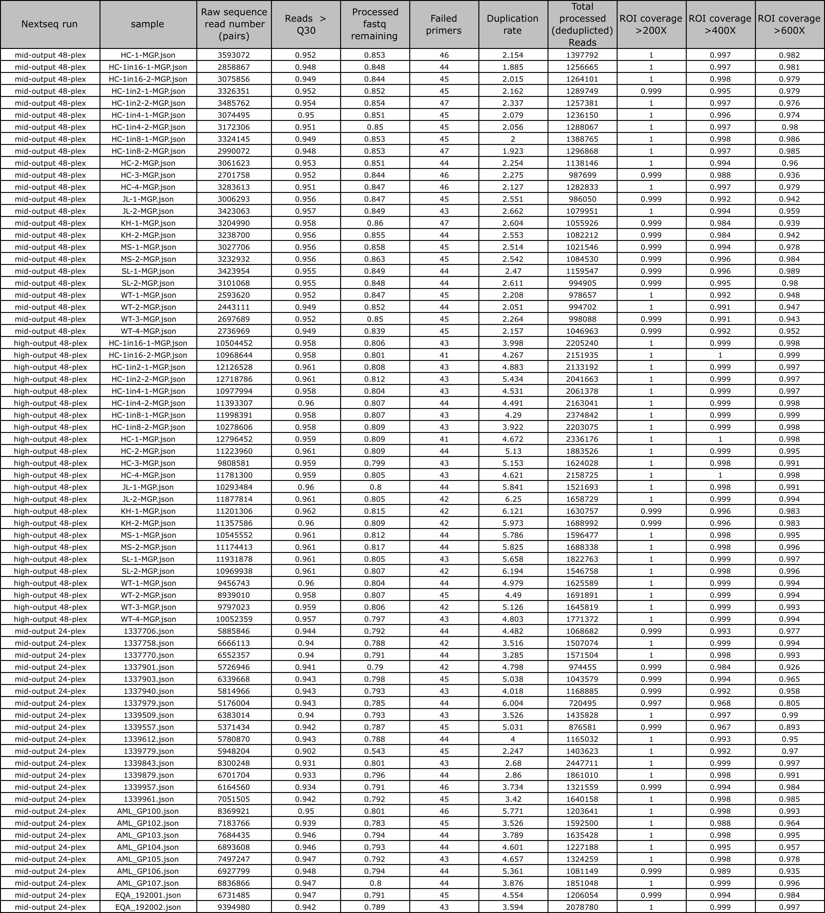

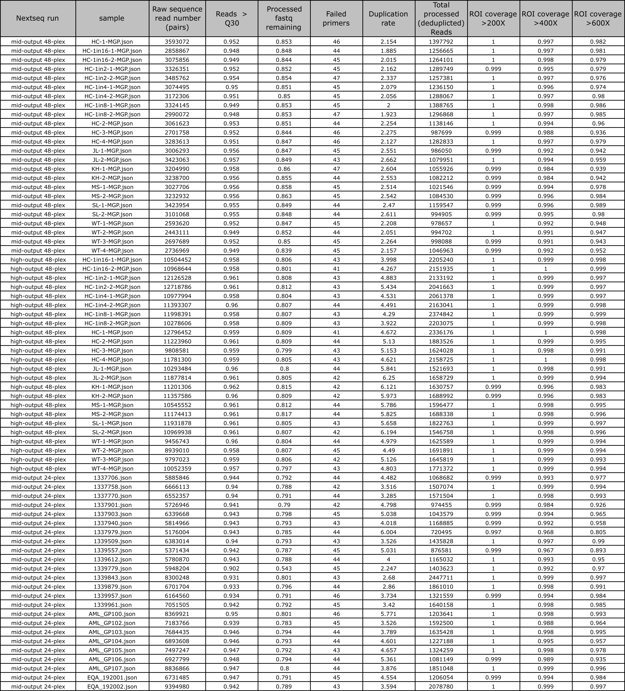

Bioinformatics report: Technical validation of Qiaseq chemistry and associated NGS data

We assessed sequence read output per target primer to demonstrate reagent set performance and provision of  
reproducible sequence data across the target region design, within and between experiments.

Relative primer amplification across independent Qiaseq experiments: A) The relative proportion of processed, de-duplicated read numbers (reads with same unique molecular identifier [UMI] merged into consensi) associated with each assay primer are displayed as a boxplot for each of the 24 independent Myeloid Qiaseq experiments run in experiment batch1 using a mid-output kit (plus an additional 24 associated with another Qiaseq panel experiment: not shown). Total sequence data is used here and normalization via sub-sampling raw read input was not performed. All boxplot inter-quartile ranges (25th-75th percentile) are shown (dense black regions). Whiskers extending from these regions indicate upper and lower extremes within 75th/25th inter-quartile ranges +/- 1.5*IQR. B: batch 2, comprising 24 independent Myeloid Qiaseq assays using a high-output Nextseq sequencing kit (plus an additional 24 of which being for another Qiaseq panel experiment: not shown).

A

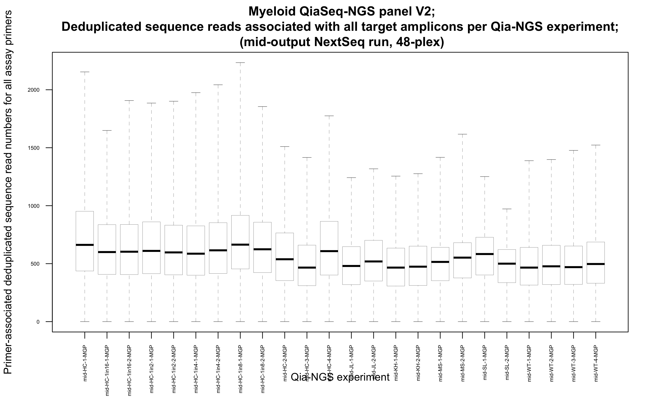

B

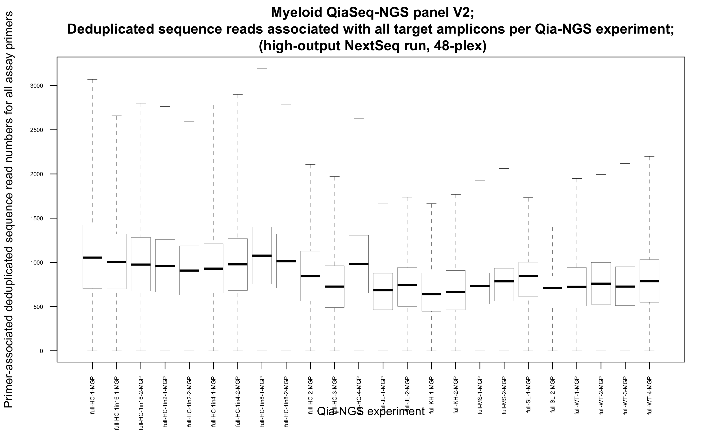

Relative primer amplification across independent experiments. The relative proportion of UMI read numbers associated with each assay primer are displayed as a boxplot using data from a representative 24 independent QiaSeq-NGS experiments (batch 1) subsequently analysed in Snappy with standard configuration; ranked left to right in order of least to most abundant target amplicon on average. Boxplot inter-quartile ranges (25th-75th percentile) are shown (grey boxes ) around median (black lines centering boxes). X axis ordered by average relative amplification (proportion).

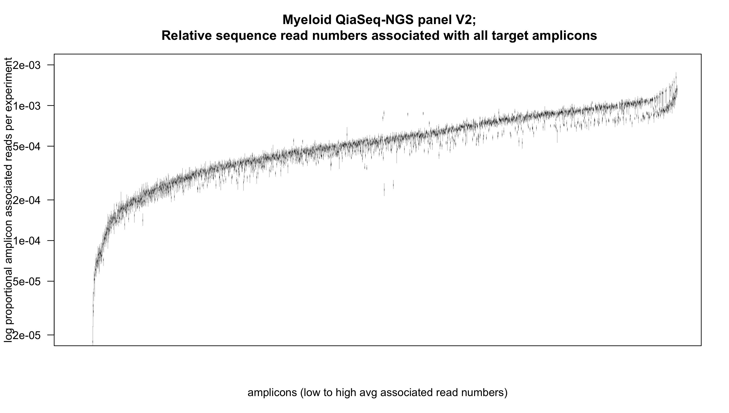

## 3.3 Interpretation

These data show that the QiaSeq method generates reliable and robust data, from library preparation, instrumentation though to data quality. This includes very good sample-to-sample consistency for targeted region amplification (per target primer) and associated read depth and ROI coverage; greater than 99.9% of ROIs are covered at 200x and greater than 99% of ROIs at 400x. Depth of coverage is also reviewed in LOD and Coverage also analysed in separate sections below) . Of particular interest is that the gene CEBPA, a very difficult gene to sequence due to its high GC content, sequences consistently at good depth (shown for representative samples, mid-output vs high-output kit, 48 sample assay run).

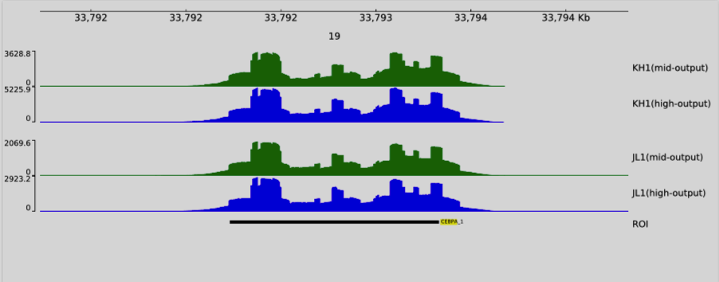

## 

## 3.4 Outcome / limitations

* The results fulfil the validation requirements for performance and robustness and meet the requirements set out in the performance criteria.

# 

# SECTION 4.0: Sensitivity, Specificity and Accuracy Validation

## 4.1 Work plan

|  |  |
| --- | --- |
| **Section aims** | To assess test accuracy based on a series of presence/absence mutation calls |
| **Samples** | Samples will be compared that have been previously been sequenced by the Myeloid Gene Panel or with known mutations with commercial standards. These include clinical samples, the Horizon standard and several NEQAS EQA samples. The Multiplex gDNA Myeloid DNA Reference Standard (#HD829) will be used (see appended Horizon specification sheet, including batch analysis for the sample used, manufactured under ISO 13485:2016 standards). This is a standards with a series of known variants which have been quantified using digital droplet PCR, which can be considered as a “gold standard” of this purpose. The variants range from 5% to 70% VAF and can thus be regarded as a challenging sample. |
| **Methodology** | Samples have been sequenced by the previously-accredited myeloid gene panel (Illumina Tru-Seq Custom Amplicon). Overlap between these data sets and the myeloid gene panel or commercial standards will be used in this analysis. This allows many mutation calls from different regions of interest to be analysed as a whole to give meaningful data. By necessity, it is only possible to compare with a limited sub-set of known mutations. The new panels are larger, so false positives in new regions of interest cannot be assessed for this validation |

As described in Mattocks *et al*,

Sensitivity = True Positive / (True Positive + False Negative).

Specificity = True Negative / (True Negative + False Positive)

Accuracy = True Result / (True Result + False Result)

## 4.2 Results

## 4.2.1 Comparison of TSCA MGP variant detection vs Qiaseq MGP

A series of samples, repeated multiple times each were analysed by both the Qiaseq MGP panel and our UKAS-accredited TSCA MGP panel. A simple qualitative present/absent score is applied. Known common artefacts have been accounted for and described below. All variants (n=161) in all samples were cross-compared.

|  |  |
| --- | --- |
| Positive concordant variants | 161 |
| Negative concordant variants | n/a$ |
| Discordant variants | 0 (4)* |
| Total | 161 |
| Concordance | 100% |

Sensitivity = 161 / (161 + 0) =100%

All expected variants were found.

Specificity = 100%

All regions known to be negative in the TSCA MGP (all regions of interest[ROI]) were also found to be negative in the overlapping ROI for the QiaSeq MGP panel, following analysis/justification of 4 variants initially seen as discordant (see below). This included removal of 2 variants found consistently in all or many samples, labelled as library/sequencing artefacts that would be marked for automatic removal subsequently. No additional variant calls were observed for the QiaSeq MGP panel assay (false positive calls) other than those which had been previously identified in the validated TSCA MGP assay (interpretation on filtered pipeline output VCF files was performed through the SQVD software and included removal of intronic variants) .

Accuracy = 100%

**Interpretation**

The combined data show:

100% sensitivity

100% specificity

100% accuracy

These results show that, at the qualitative level, the QiaSeq MGP method is 100% accurate using these tests (excluding known artefacts which arise in one panel vs the other: listed below).

**$: Negative concordant variants:** an analysis of the entire ROI revealed that all regions, other than those known to contain a variant, were negative in both QiaSeq MGP and TSCA MGP, following justification for 4 discordant variants (below).

**\* Summary of discordant variant analysis:** several variants were discovered which were discordant (specific to Qiaseq assay), however, following further analysis of data, it was evident that these discrepancies were attributed to assay chemistry or alignment artefacts and were consistent through all/many samples, and could therefore be discounted in subsequent analysis (marked for automatic removal,, or they were correctly detected in the QiaSeq MGP, where the TSCA MGP has been unable to detect these variants due to design constraints.

**Discordant Variant FLT3-ITD:** NM_004119.3:c.1829_1830insGACCGGCTCCTCAGATAATGAGTACTTCTACGTTGATTTCAGAGAATATGAATATGATCTCAAATGGGAGTTTCCAAGAGAAAATTT (87bp).

NP_004110.2: p.Thr582_Leu610dup

Sample SL: TSCA = negative, QiaSeq = positive

Conclusion: due to its design and analysis pipeline, the QiaSeq method is superior to TSCA for detection of larger indels. The TSCA pipeline is only able to detect indels of less than 60bp.

**Discordant Variant in GATA2:**

NM_032638.5:c.966C>T (p.Tyr322=) 3-128202754-G-A.

All QiaSeq samples: positive at ~5%, TSCA negative.

Conclusion: Likely process/chemistry artefact. Consistent background. Mark for automatic removal.

**Discordant Variant in GATA2:**

NM_032638.5:c.784A>C (p.Ser262Arg) 3-128204657-T-G

Many QiaSeq samples: positive at ~30%, TSCA negative

Conclusion: primer specific/bias; 3’ end read effect, possibly a NextSeq-specific event adding Gs to end of reads. Likely process/chemistry artefact. Consistent background. Mark for automatic removal..

**Discordant Variant in ZRSR2:**

In sample 1339879, QiaSeq MGP calls a variant as follows:

X-15827443-TAAC-CAAT, NM_005089.3:c.557+2_557+5delinsCAAT, NP_005080.1:p.?, 11% VAF.

TSCA MGP: negative. This will be noted in as a query true positive not picked up by legacy assay (complex variant; see bioinformatic report below). Note: Both QiaSeq and TSCA call a second genuine variant at the same position as follows: NM_005089.3:c.557+2T>C, X-15827443-T-C, 87% and 91.17% VAF respectively.

## 

## 4.2.2 Comparison of TSCA variant detection results vs Qiaseq LGP

Using all data from 56 variants found. A sub-set of genes are common to both the TSCA MGP and the QiaSeq LGP. These are included in the following analysis.

|  |  |
| --- | --- |
| Positive concordant variants | 56 |
| Negative concordant variants | n/a$ |
| Discordant variants | 0 (2)* |
| Total | 56 |
| Concordance | 100% |

Sensitivity = 56 / (56 + 0) =100%

All expected variants were found.

Specificity = 100%

All regions known to be negative in the TSCA was also found to be negative in the QiaSeq LGP panel (true negative). No unexpected variants (false positives) were observed in the QiaSeq LGP panel in overlapping regions of interest other than those which had been previously identified in the TSCA MGP.

Accuracy = 100%

**Interpretation**

The combined data show:

100% sensitivity

100% specificity

100% accuracy

These results show that, at the qualitative level, the QiaSeq LGP method is 100% accurate using these tests (excluding known artefacts which arise in one panel vs the other).

$: Negative concordant variants: an analysis of the entire ROI revealed all regions, other than those known to contain a variant, were negative in both QiaSeq LGP and TSCA, from which can be inferred a 100% negative (no false positive) concordance.

* Summary of discordant variant analysis:

Two low-level variants appear in the QiaSeq LGP analysis of sample MS, which does not appear in the original TSCA.

Sample MS-1: coordinate: chr17:7579472. GG>CA 5.03% VAF

Sample MS-2: coordinate: chr17:7579472.GGGGGA>CGGGGG 5.18% VAF

There is a genuine homozygous SNV at this position. An analysis of the BAM file in IGV, reveals the lower VAF variants to be artefacts and can thus be discounted.

## 4.2.3 Bioinformatics technical assessment of sensitivity/specificity

Assay sensitivity here is the performance of the assay in variant detection. This was for a set of known validated variants within a defined set of clinical samples and appropriate controls.

Assay specificity is a quantitative assessment of false positive (FP) calls. In a clinical setting, if an assay has 100% specificity then it should not produce an aberrant positive result in respect to its intended purpose. For DNA sequencing assays, the size of the region screened will proportionally increase the likelihood of detecting a false positive variant call, assuming all else is equal. For example, a pyrosequencing assay which interrogates 30 base pairs is likely to have much higher overall assay specificity than and NGS assay which screens a region of 100kb, even if the pyrosequencing assay has an relatively high per base FP rate. Thus, either our expectations and assay acceptance criteria should be proportionally different for these two assay types, or a normalization step should be considered if specificity measures between such assays can be directly comparable.

**Variant detection performance; Qiaseq MGP assay**

|  |  |  |  |
| --- | --- | --- | --- |
| SNV + Indel | Measure | Metric | Error (95% CI) or significance |
| Sensitivity (detection), n=224 | Detection of validated variants (≥3.5% VAF) | 100% | ±1.3% |
| Specificity, n=224 (n=8493) | Detection of validated wild type reference; absence of false positives ≥3-5% VAF | 100% (99-100%%) | ±1.3% (±0.004%) |

Sensitivity is a measure of performance in variant detection based on a validated variant set for 19 patients (VAF >0.035), 9 EQA and 1 horizon control sample (unique independent samples; repeats and dilutions not included). Snappy pipeline thresholds were set at 0.02 VAF and 6 supporting reads (VD 6), to allow for sub-sampling error. The validated variant set was provided by the LMH laboratory as the output from the legacy MGP assay. Detection of validated variants was 100%.

Specificity assessment was based on absence of non-validated variants (false positives) based on : 1. regions around known variants (+/- 50bp), in line with a typical qPCR assay or individual NGS ROI, for which the known variant should be the only non-reference sequence change (>0.03 VAF); 2. For 19 patient samples only, across the complete assay region of interest (ROI) for variants (>0.05 VAF) not included in the total variant complement outputted by the validated MGP assay (sample VCF files). An ROI region in the Qiaseq panel design was designated as a single unit (region) for specificity calculation here (19 x447=8493). 7 additional calls were initially seen and either justified as non-false positive events (6) or accepted as likely persistent false positive call (1) to be marked for automatic removal in future analyses. See specific report sections for further details. Calculations of confidence intervals were based on 3/n (n=variants or regions).

All regions around known variants (+/- 50bp) seen for legacy MGP were negative in Qiaseq assay.

All regions known to be negative in the TSCA MGP (all regions of interest[ROI]) were also found to be negative in the overlapping ROI for the QiaSeq MGP panel, following analysis/justification of 6 variants initially seen as discordant (see below; according to filtered VCF outputted by Snappy for full ROI). This included removal of 3 variants found consistently in all or many samples, labelled as laboratory process/chemistry artefacts that would be marked for automatic removal subsequently. No additional variant calls were observed for the QiaSeq MGP panel assay (false positive calls) other than those which had been previously identified in the validated TSCA MGP assay (sample associated VCF outputs) or which were assessed to be likely true variants missed by Legacy MGP analysis .

Discordant variants: bioinformatics report

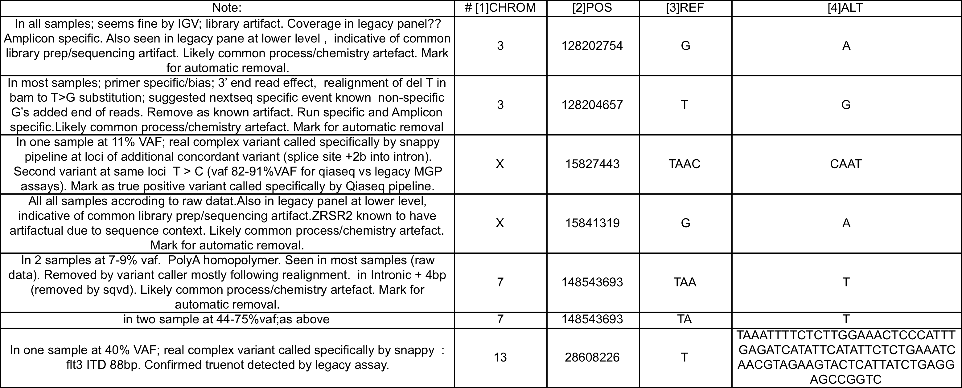

**Validated variants for validation of Qiaseq assay variant detection and quantification**

**(unique samples)**

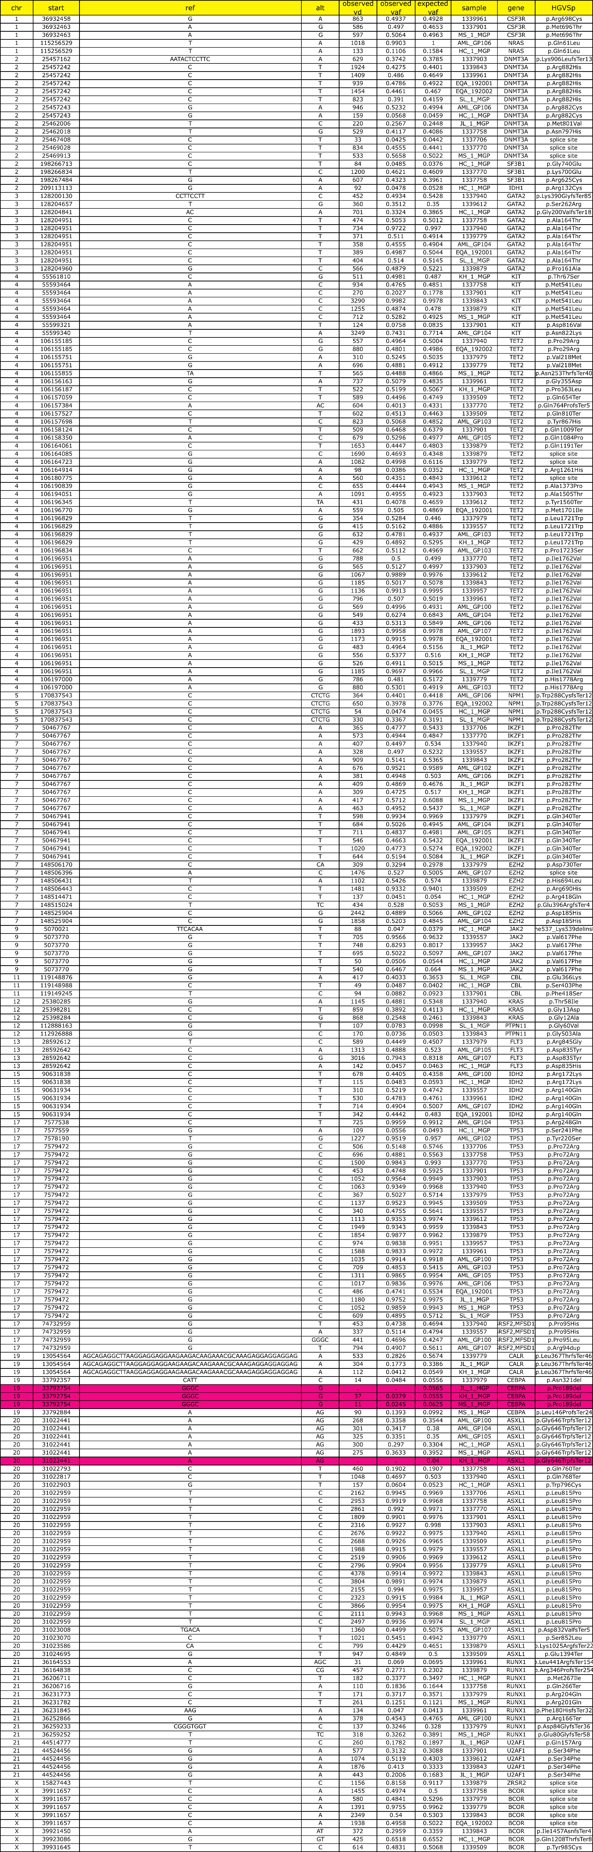



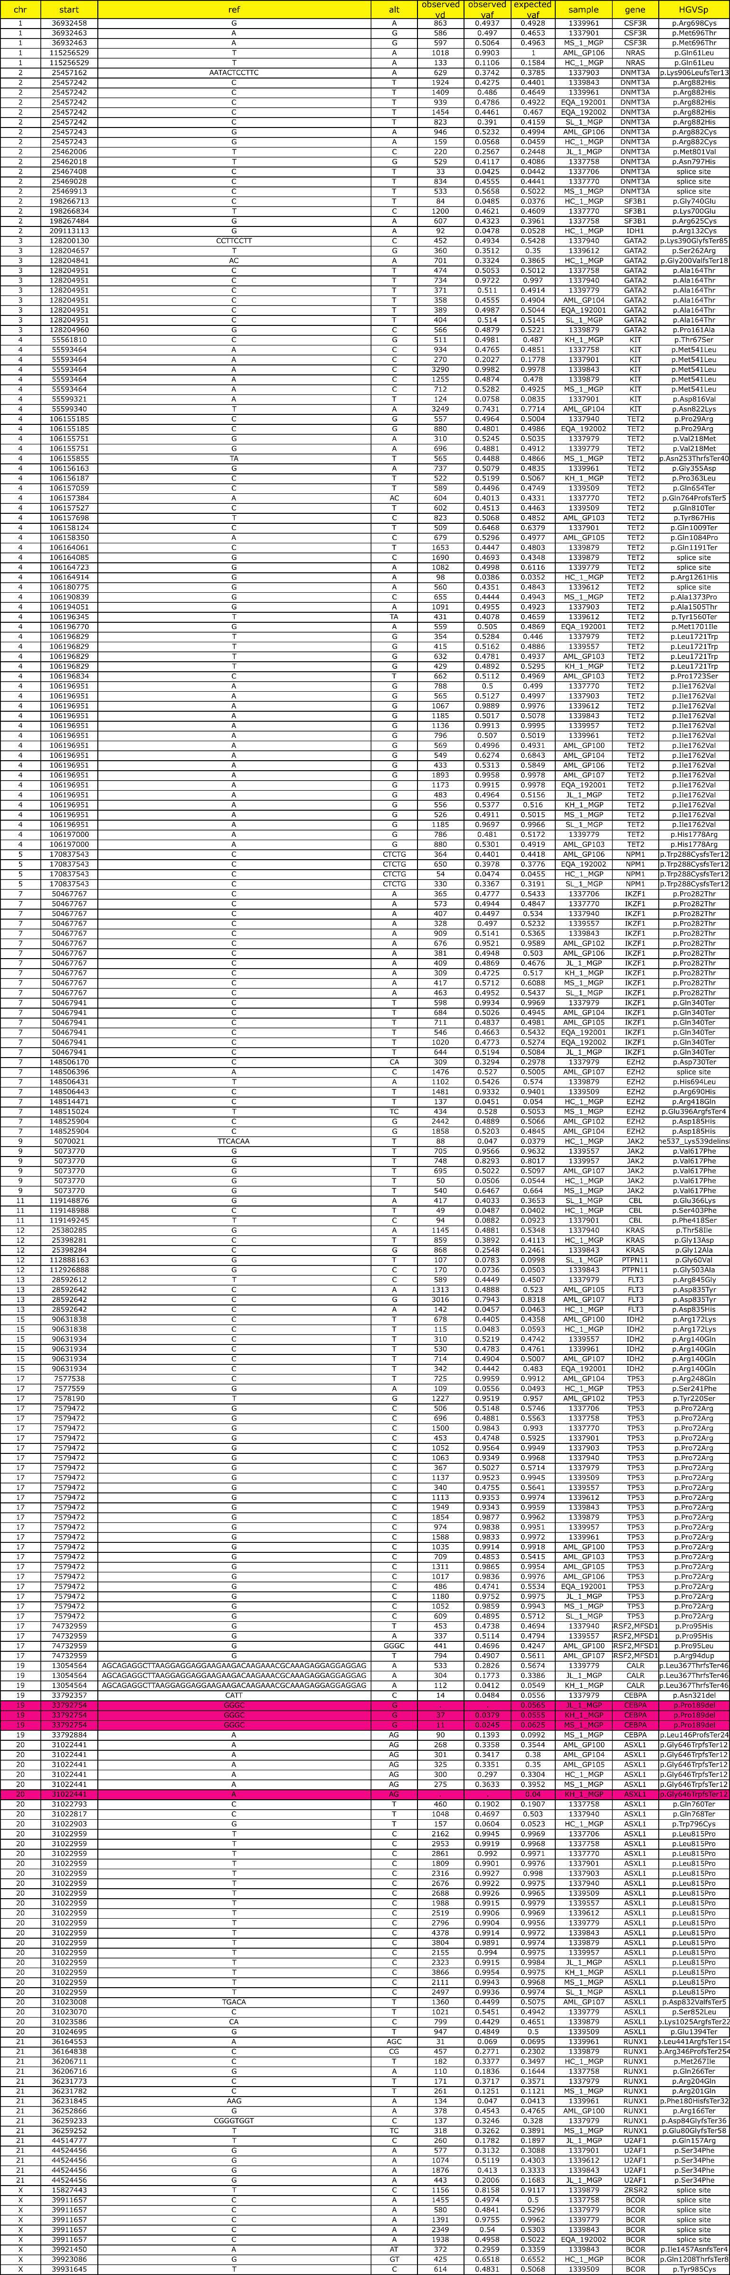





**Variant set for validations**. In total, 228 variants from independent and unique patient and control samples were assessed. Sample assays repeats were not included here. Expected variant allele frequencies (VAF) values represent those outputted from the validated legacy Myeloid gene panel (LMH MGP Illumina assay). Observed values represent those associated with the Myeloid Qiaseq assay being validated here (Snappy analysis). EQA samples are those prefixed with either ‘AML’ or ‘EQA’ . Horizon control sample (HC829) is prefixed with HC. Gene and protein effect are also listed here as derived from the validated variant LMH pipeline. VD values represent variant depth (reads supporting the variant). Variants highlighted in red represent known common artifacts from legacy MGP assay included initially in validation set , and removed from further analysis subsequently. For these known false positive results, it is noted that the ASXL1 mutation (Insertion of a G) is a known pathogenic mutation but is associated with a false positive background event giving the same mutation annotation at a relatively low VAF value (see laboratory report). This is associated with a homopolymeric run of G residues and problematic sequencing/analysis associated with such regions. For this mutation, it is widely accepted that only mutations with a VAF > 0.1 are reported. It is therefore of note that the Qiaseq assay did not detect this ASXL1 mutation at the VAFs outputted by the Illumina assay. The CEBPA false positive mutation was outputted by both pipelines but at a VAF value below primary threshold required in the assay validation acceptance criteria (0.05 VAF).

## 4.3: Outcome / limitations

* The QiaSeq pipeline detects all expected variants. With the exception of several artefacts, which are likely due to alignment issue and can therefore be regarded as an artefact, no non-specific variants or background at the 5% level is detected.
* These results represent an unbiased analysis to evaluate the QiaSeq’s performance accuracy at the qualitative level.
* This partial analysis does not address quantitative parameters.
* The QiaSeq method gives superior results in terms of detecting indels. Only 6 discrepancies were found and these were obvious artefacts and can be discounted from the accuracy calculation.

## 4.3: Conclusions

* The results fulfil the validation requirements for accuracy and meet the requirements set out in the performance criteria.

# SECTION 5.0: Trueness Validation / Verification

If this is not required enter Not Applicable and state why (refer also to Table 1) and delete the Work plan & Partial results and conclusions sections

## 5.1 Work plan

|  |  |
| --- | --- |
| **Section aims** | The QiaSeq performance can be assessed for Trueness where quantitative variant allele burden data is available from a standardised material |
| **Samples** | Several repeat tests will be carried out using the Horizon Diagnostics Multiplex gDNA Myeloid DNA Reference Standard (#HD829) (see appended Horizon specification sheet, including batch analysis for the sample used, manufactured under ISO 13485:2016 standards). This is a standards with a series of known variants which have been quantified using digital droplet PCR, which can be considered as a “gold standard” of this validation. The variants range from 5% to 70% VAF and can thus be regarded as a challenging sample. In addition, previously analysed patient samples will be used. |
| **Methodology** | Myeloid and lymphoid QiaSeq library preparations will be carried out of per protocol LP-XXXX. Currently, only a sub-set of LGP variants can be analysed with the Horizon control, as this control is designed specifically for myeloid analysis. However, there are 7 genes in the Horizon control which have a variant that should be detectable using the LGP. Samples were run using both high and mid-output kits on the Illumina NextSeq550 instrument. Standard correlation and Bland-Altman analysis will be used. This bias analysis, calculates the value determined by one method minus the value determined by the other method (Horizon control values). If one method is sometimes higher, and sometimes the other method is higher, the average of the differences will be close to zero. If it is not close to zero, this indicates that the two assay methods are systematically producing different results. The standard deviation (SD) of the differences between the two assay methods (labelled as the SD of bias) is used to calculate the limits of agreement, computed as the mean bias plus or minus 1.96 times its SD. |

## 5.2 Results

## QiaSeq MGP Trueness data using multiple repeats under different run conditions

The Horizon Myeloid standard control samples were analysed using the QiaSeq MGP after being run multiple times under different run conditions. The table shows the expected %VAF of each variant and the corresponding results of the samples.

|  |  |  |  |  |  |  |  |  |  |
| --- | --- | --- | --- | --- | --- | --- | --- | --- | --- |
| Gene and variant | Expected | HC-1H | HC-2H | HC-3H | HC-4H | HC-1M | HC-2-M | HC-3M | HC-4M |
| ASXL1 G646fs*12 | 39.40 | 31 | 29 | 31 | 31 | 30 | 26 | 28 | 29 |
| ASXL1 W796C | 4.89 | 7 | 6 | 5 | 5 | 6 | 6 | 5 | 4 |
| BCOR Q1174fs*8 | 66.10 | 68 | 67 | 64 | 69 | 65 | 65 | 67 | 66 |
| CBL S403F | 4.95 | 5 | 7 | 5 | 3 | 5 | 7 | 4 | 3 |
| DNMT3A R882C | 4.71 | 5 | 5 | 5 | 5 | 6 | 5 | 4 | 5 |
| EZH2 R418Q | 4.66 | 5 | 5 | 4 | 6 | 5 | 5 | 4 | 5 |
| FLT3 D835Y | 5.22 | 4 | 5 | 6 | 5 | 5 | 5 | 6 | 5 |
| GATA1 Q119* | 11.00 | 9 | 11 | 9 | 13 | 9 | 10 | 11 | 12 |
| GATA2 G200fs*18 | 34.60 | 33 | 36 | 33 | 33 | 33 | 32 | 33 | 32 |
| IDH1 R132C | 4.78 | 6 | 3 | 5 | 5 | 5 | 4 | 5 | 4 |
| IDH2 R172K | 5.14 | 5 | 5 | 31 | 6 | 5 | 5 | 5 | 6 |
| JAK2 F537 K539>L | 5.02 | 5 | 4 | 5 | 4 | 5 | 5 | 4 | 5 |
| JAK2 V617F | 5.04 | 5 | 5 | 4 | 4 | 5 | 4 | 5 | 4 |
| KRAS G13D | 37.90 | 40 | 41 | 40 | 41 | 39 | 41 | 37 | 41 |
| NPM1 W288fs*12 | 5.02 | 4 | 4 | 7 | 5 | 5 | 5 | 6 | 5 |
| NRAS Q61L | 10.20 | 11 | 10 | 10 | 13 | 11 | 10 | 9 | 11 |
| RUNX1 M267I | 34.20 | 33 | 37 | 30 | 34 | 34 | 34 | 29 | 35 |
| SF3B1 G740E | 4.96 | 5 | 6 | 4 | 5 | 5 | 6 | 5 | 6 |
| TET2 R1261H | 4.77 | 4 | 5 | 5 | 5 | 4 | 5 | 5 | 5 |
| TP53 S241F | 5.17 | 5 | 5 | 6 | 5 | 6 | 5 | 6 | 5 |
| FLT3-ITD (300bp) | 4.87 | not found | not found | not found | not found | not found | not found | not found | not found |

The FLT3-ITD variant was not found in our analysis, but this is expected at the informatics pipeline is only able to detect indels of up to ~200bp. In any case, suspected acute myeloid leukaemia samples would be analysed by conventional FLT3 fragment analysis which is a more robust and reliable method for detecting all sizes of FLT3 ITDs.

The QiaSeq MGP data is also represented in the following cluster plot, showing each data point, with the expected Horizon %VAF shown in red.

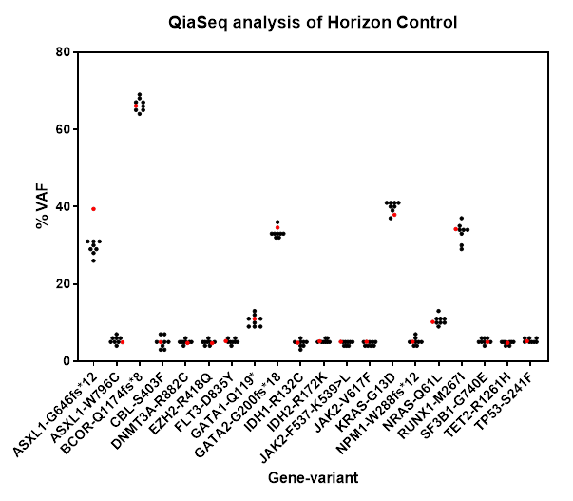

The data is are also represented in the following bar chart, with the expected Horizon % VAF shown in red and the actual result shown as a mean and SD, with the data table below.

|  |  |  |  |
| --- | --- | --- | --- |
| Variant | QiaSeq %VAF | Expected %VAF (Horizon) | SD |
| ASXL1-G646fs*12 | 29 | 39.4 | 1.8 |
| ASXL1-W796C | 5.5 | 4.89 | 0.93 |
| BCOR-Q1174fs*8 | 66 | 66.1 | 1.7 |
| CBL-S403F | 4.9 | 4.95 | 1.6 |
| DNMT3A-R882C | 5 | 4.71 | 0.53 |
| EZH2-R418Q | 4.9 | 4.66 | 0.64 |
| FLT3-D835Y | 5.1 | 5.22 | 0.64 |
| GATA1-Q119* | 11 | 11 | 1.5 |
| GATA2-G200fs*18 | 33 | 34.6 | 1.2 |
| IDH1-R132C | 4.6 | 4.78 | 0.92 |
| IDH2-R172K | 5.3 | 5.14 | 0.46 |
| JAK2-F537-K539>L | 4.6 | 5.02 | 0.52 |
| JAK2-V617F | 4.5 | 5.04 | 0.53 |
| KRAS-G13D | 40 | 37.9 | 1.4 |
| NPM1-W288fs*12 | 5.1 | 5.02 | 0.99 |
| NRAS-Q61L | 11 | 10.2 | 1.2 |
| RUNX1-M267I | 33 | 34.2 | 2.6 |
| SF3B1-G740E | 5.3 | 4.96 | 0.71 |
| TET2-R1261H | 4.8 | 4.77 | 0.46 |
| TP53-S241F | 5.4 | 5.17 | 0.52 |

A Bland-Altman analysis showing the bias between the QiaSeq MGP method and the expected Horizon standards.



|  |  |
| --- | --- |
| Bias | -0.4865 |
| SD of bias | 2.446 |
| 95% Limits of Agreement |  |
| From | -5.282 |
| To | 4.309 |

## QiaSeq Lymphoid Gene Panel Trueness data using multiple repeats

|  |  |  |  |  |  |  |  |
| --- | --- | --- | --- | --- | --- | --- | --- |
|  | DNMT3A-R882C | EZH2-R418Q | IDH2-R172K | KRAS-G13D | NRAS-Q61L | TET2-R1261H | TP53-S241F |
| HC-1-LGP | 5.63 | 4.33 | 6.66 | 40.48 | 8.46 | 4.39 | 4.67 |
| HC-2-LGP | 4.42 | 4.54 | 5.47 | 35.71 | 14.58 | 4.69 | 5.77 |
| HC-3-LGP | 4.05 | 4.8 | 6.79 | 39.44 | 7.29 | 5.78 | 4.73 |
| HC-4-LGP | 5.61 | 4.57 | 4.27 | 40.01 | 9.71 | 3.89 | 5.95 |
|  |  |  |  |  |  |  |  |
| Number of values | 4 | 4 | 4 | 4 | 4 | 4 | 4 |
| Minimum | 4.1 | 4.3 | 4.3 | 36 | 7.3 | 3.9 | 4.7 |
| Maximum | 5.6 | 4.8 | 6.8 | 40 | 15 | 5.8 | 6 |
| Range | 1.6 | 0.47 | 2.5 | 4.8 | 7.3 | 1.9 | 1.3 |
| 5% Percentile | 4.1 | 4.3 | 4.3 | 36 | 7.3 | 3.9 | 4.7 |
| 95% Percentile | 5.6 | 4.8 | 6.8 | 40 | 15 | 5.8 | 6 |
| Mean | 4.9 | 4.6 | 5.8 | 39 | 10 | 4.7 | 5.3 |
| Std. Deviation | 0.81 | 0.19 | 1.2 | 2.2 | 3.2 | 0.8 | 0.67 |
| Std. Error of Mean | 0.41 | 0.096 | 0.59 | 1.1 | 1.6 | 0.4 | 0.34 |
| Lower 95% CI of mean | 3.6 | 4.3 | 3.9 | 35 | 4.9 | 3.4 | 4.2 |
| Upper 95% CI of mean | 6.2 | 4.9 | 7.7 | 42 | 15 | 6 | 6.4 |
| Coefficient of variation | 17% | 4.2% | 20% | 5.6% | 32% | 17% | 13% |

**Summary data**

|  |  |  |  |
| --- | --- | --- | --- |
| **Variant** | **QiaSeq LGP (mean)** | **Expected (Horizon)** | **SD** |
| DNMT3A-R882C | 4.9 | 4.71 | 0.81 |
| EZH2-R418Q | 4.6 | 4.66 | 0.19 |
| IDH2-R172K | 5.8 | 5.14 | 1.2 |
| KRAS-G13D | 39 | 37.9 | 2.2 |
| NRAS-Q61L | 10 | 10.2 | 3.2 |
| TET2-R1261H | 4.7 | 4.77 | 0.8 |
| TP53-S241F | 5.3 | 5.17 | 0.67 |

**Bland-Altman analysis:** showing the bias between the QiaSeq LGP method and the expected Horizon standards.



|  |  |
| --- | --- |
| Bias | 0.25 |
| SD of bias | 0.4672 |
| 95% Limits of Agreement | |
| From | -0.6657 |
| To | 1.166 |

## 5.3 Interpretation

The quantitative statistical correlations for all variants in the standard material are extremely high and the Bland-Altman analysis shows a very small bias of -0.4865 and 0.25 %VAF for the MGP and LGP respectively, which in terms of this assay, can be regarded as essentially ideal. This assay has a very high level of Trueness.

## 5.4 Outcome / limitations

* The results fulfil the validation requirements for Trueness and meet the requirements set out in the performance criteria.

# SECTION 6.0: Linearity Validation / Verification

## 6.1 Work plan

|  |  |
| --- | --- |
| **Section aims** | The QiaSeq performance can be assessed for linearity where quantitative variant allele burden is also available from previous data from the accredited TSCA assay as well as the Horizon reference standards. |
| **Samples** | Several repeat tests will be carried out using two types of samples, which together will generate a large data set. The Multiplex gDNA Myeloid DNA Reference Standard (#HD829) will be used (see appended Horizon specification sheet, including batch analysis for the sample used, manufactured under ISO 13485:2016 standards). This is a standards with a series of known variants which have been quantified using digital droplet PCR, which can be considered as a “gold standard” of this purpose. The variants range from 5% to 70% VAF and can thus be regarded as a challenging sample. In addition, previously analysed clinical samples will be assessed |
| **Methodology** | Myeloid QiaSeq library preparations will be carried out of per protocol HAE-LP-XXXX. Samples will be run using both high and mid-output kits on the Illumina NextSeq550 instrument. An r2 correlation will be used to assess linearity. |

## 6.2 Results

Data from 3 independent experiments comprising a total of 40 independent sample library preparations with a total of 324 analysed variants, was analysed to assess correlation between the new QiaSeq MGP results and the combined data from the Horizon controls and the accredited TSCA assay.

|  |  |
| --- | --- |
| Pearson r |  |
| R | 0.9951 |
| 95% confidence interval | 0.9939 to 0.9960 |
| R squared | 0.9902 |
|  |  |
| P value |  |
| P (two-tailed) | <0.0001 |
| P value summary | **** |
| Significant? (alpha = 0.05) | Yes |

Data from 4 independent sample library preparations with a total of 56 analysed variants, was analysed to assess correlation between the new QiaSeq LGP results and the combined data from the Horizon controls and the accredited TSCA assay.

|  |  |
| --- | --- |
| Pearson r |  |
| R | 0.9965 |
| 95% confidence interval | 0.9941 to 0.9980 |
| R squared | 0.9931 |
|  |  |
| P value |  |
| P (two-tailed) | <0.0001 |
| P value summary | **** |
| Significant? (alpha = 0.05) | Yes |

## Technical Bioinformatics Analysis of QiaSeq MGP

|  |  |  |  |
| --- | --- | --- | --- |
| **SNV + Indel** | **Measure** | **Metric** | **Error (95% CI) or significance** |
| Trueness - Accuracy  (n=224) | VAF correlation for validated *vs* observed variants) | R=0.99 | p<2.2e-16 |
| Reproducibility – Accuracy  (n=19*4) | VAF correlation across repeated independent assays | Rmedian=0.996 (±0.0018SD) | pmedian<2.2e-16 |

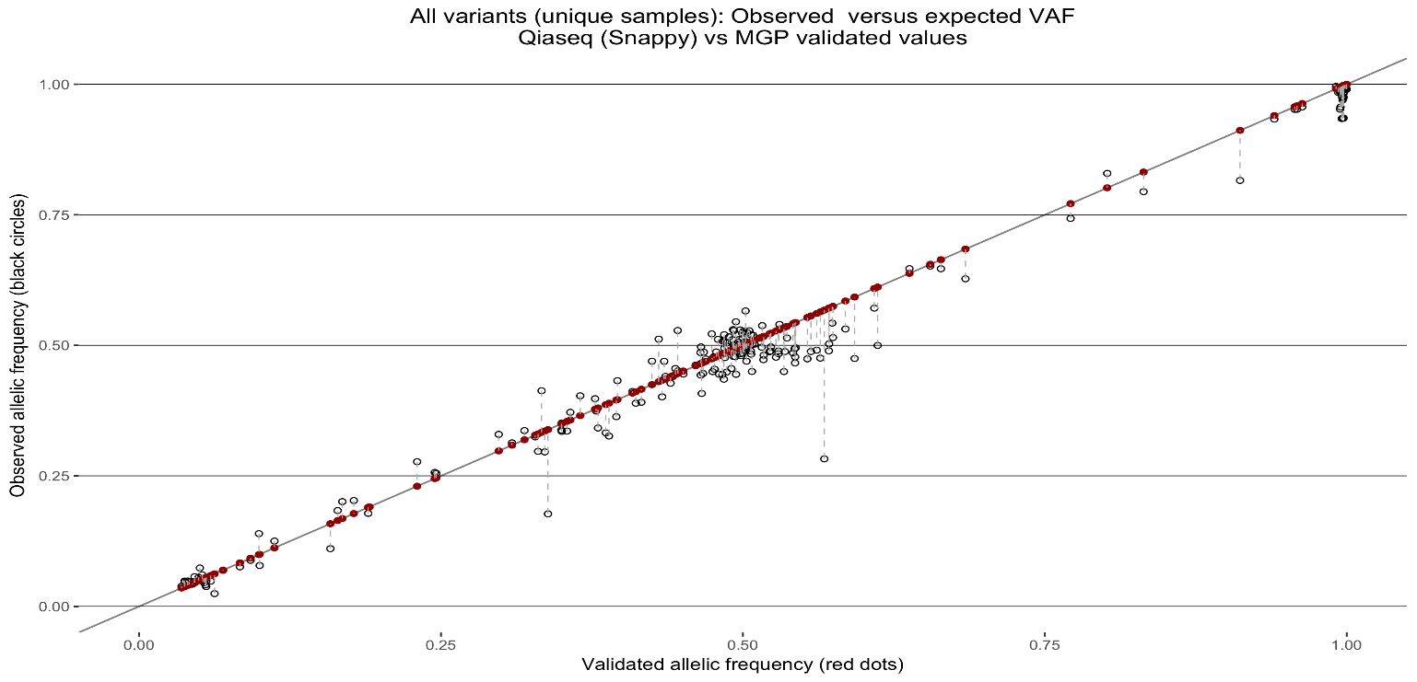

Validation variant set; observed *vs* expected VAF. For all variants in validation set (for all unique independent samples), expected VAF values (validated legacy TSCA MGP output; red points) were plotted against observed values coming from Qiaseq MGP (Snappy analysis; black circles). Comparative VAF values were seen to fall close to each other for the most part. Correlation is assessed in figure below

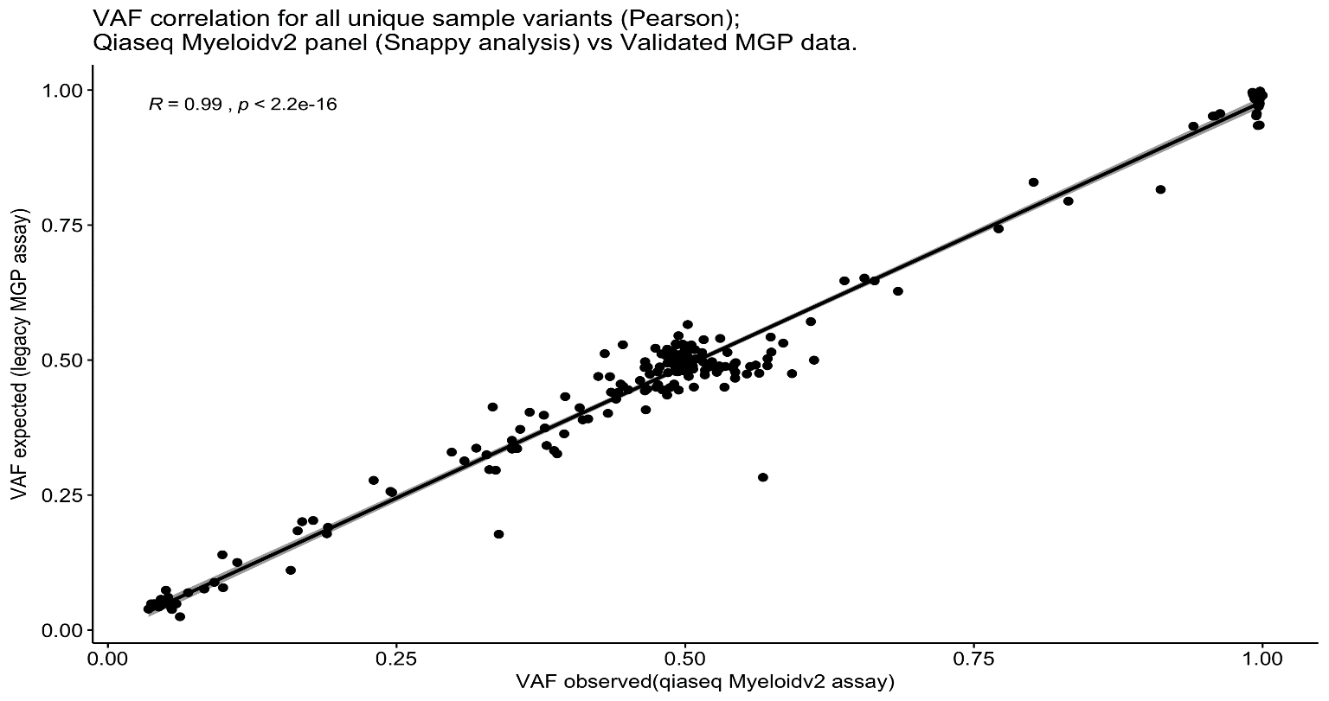

All variants in validation set were analyzed for ‘trueness’ (Pearson correlation) between the validated (expected) and observed VAF data (validated legacy MGP *vs* Myeloid Qiaseq assay). A high overall correlation was observed across the complete VAF range.

Correlation of VAF values between experimental pairings of 4 repeated Qia-NGS experiments (Pearson correlation):



## 

## 6.3 Interpretation

**This large data set (MGP and LGP) demonstrates an excellent level of correlation and linearity, with an r2 value of >0.99.**

## 6.4 Outcome / limitations

The results fulfil the validation requirements for Linearity and meet the requirements set out in the performance criteria

# SECTION 7.0: Repeatability Validation / Verification

(within-run precision or intra-assay precision)

## 7.1 Work plan

|  |  |
| --- | --- |
| **Section aims** | The aim is to assess repeatability or intra-assay precision of the QiaSeq MGP, which can also be used as a part of overall precision measurement. |
| **Samples** | Several repeat tests will be carried out using two types of samples, which together will generate a large data set. The Multiplex gDNA Myeloid DNA Reference Standard (#HD829) will be used (see appended Horizon specification sheet, including batch analysis for the sample used, manufactured under ISO 13485:2016 standards). This is a standards with a series of known variants which have been quantifies using digital droplet PCR, which can be considered as a “gold standard” of this purpose. The variants range from 5% to 70% VAF. |
| **Methodology** | The same IQC material will be assayed multiple times in one experiment  Statistical analysis will be performed and the data used measurement uncertainty calculations detailed in a later section. This will form part of the overall precision calculation. |

## 7.2 Results

A statistical analysis to show inter-sample variability with all Horizon control variants





Repeatability calculations across all variants in the Horizon control.

## Technical Bioinformatics assessment of repeatability

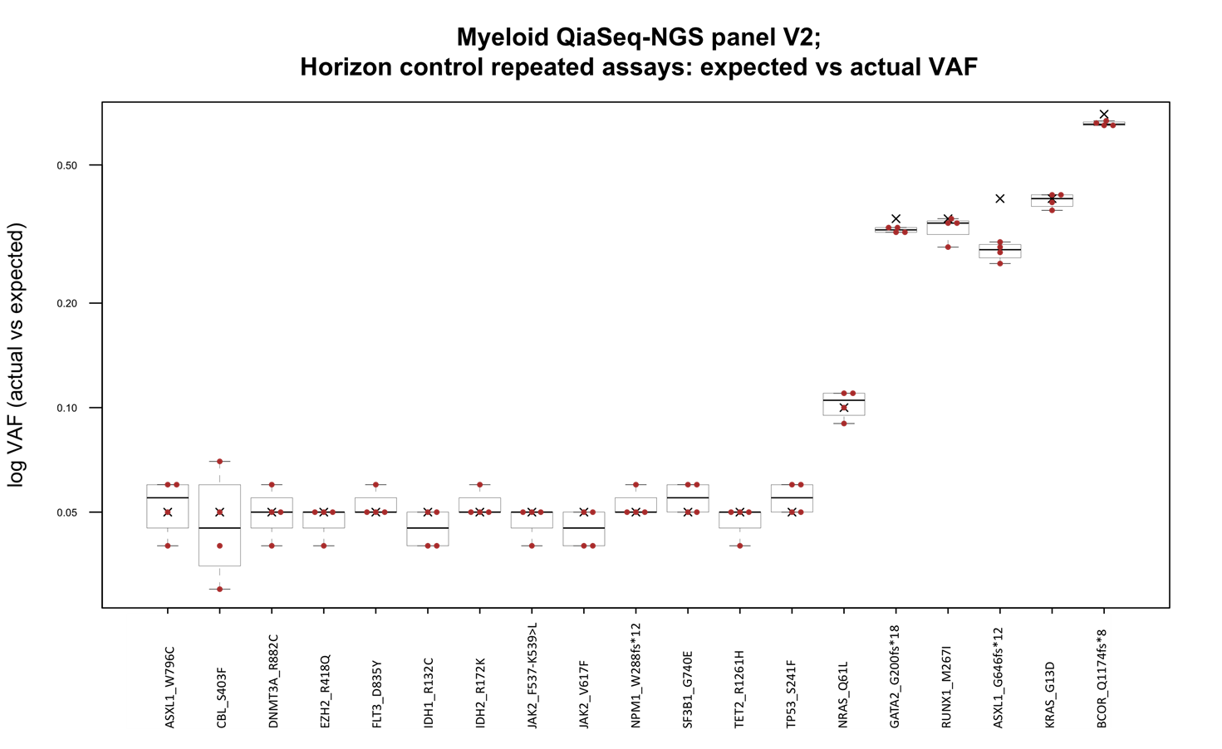

**Repeatability of Qiaseq MGP assay *vs* HC-confirmed VAF.** The variant allele frequencies of 19 validated-assured variants found in horizon control HC829 were plotted for repeated assays. Boxplots show spread of VAF values (rounded to nearest percentage point) for 4 readings per variant derived from four independent Qia-NGS experiments and Snappy analyses (pink spots). Black crosses indicate the published expected VAF values (Horizon validated values[rounded]). Boxplot inter-quartile ranges (25th-75th percentile) are shown (dense black regions). Whiskers extending from these regions indicate upper and lower extremes within 75th/25th interquartile ranges +/- 1.5*IQR

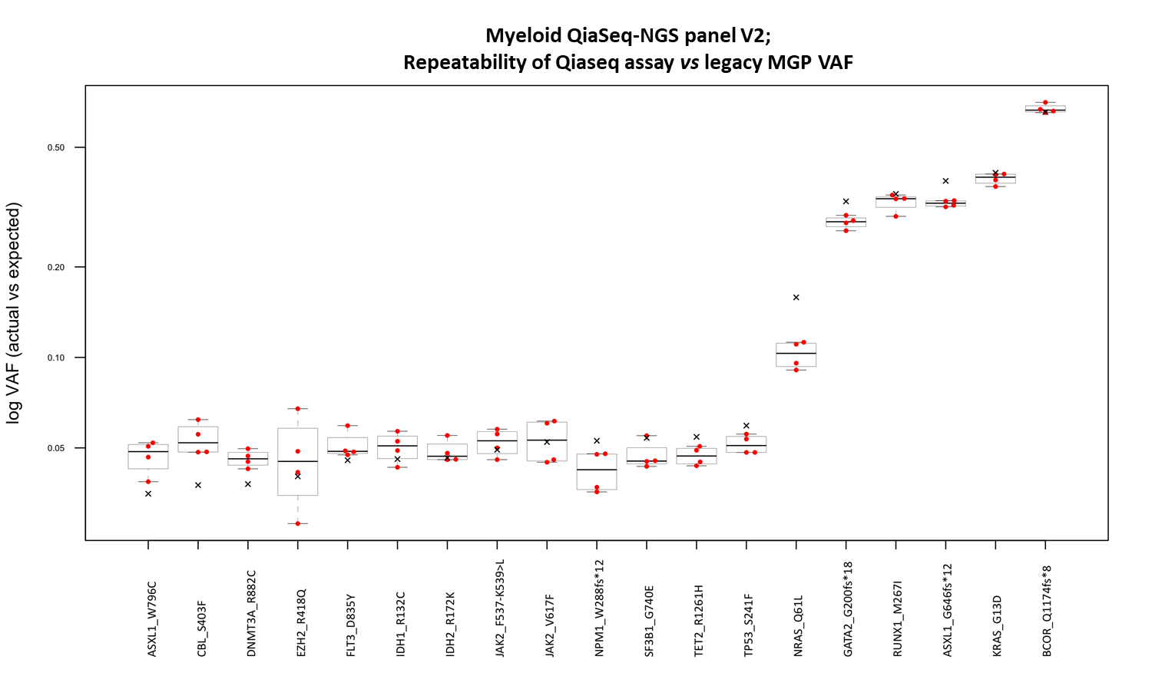

**Repeatability of Qiaseq assay *vs* legacy MGP VAF.** The variant allele frequencies of 19 validated-assured variants found in horizon control HC829 were plotted for four repeated assays. Boxplots show spread of VAF values (rounded to nearest percentage point) for 4 readings per variant derived from four independent Qiseq experiments and Snappy analyses (pink spots). In this case, black crosses indicate the validated expected VAF values derived from the legacy MGP assay output. ). Boxplot inter-quartile ranges (25th-75th percentile) are shown (dense black regions). Whiskers extending from these regions indicate upper and lower extremes within 75th/25th interquartile ranges +/- 1.5*IQR. Correlation values for the 6 pair combinations for QiaSeq repeat experiments (x4), are shown in table 7

## 7.3 Interpretation

These repeatability data show a very good consistency between samples on the same run. Particularly the low-level variants which are more challenging.

## 7.4 Outcome / limitations

These data show that the assay performs well with a good level of repeatability (intra-assay precision). The results fulfil the validation requirements for repeatability and meet the requirements set out in the performance criteria.

# SECTION 8.0 : Intermediate precision Validation / Verification

(within-laboratory, between-run precision or inter-assay precision)

If this is not required enter Not Applicable and state why (refer also to Table 1) and delete the Work plan & Partial results and conclusions sections

## 8.1 Work plan

|  |  |
| --- | --- |
| **Section aims** | The aim is to assess intermediate precision as a part of overall precision measurement. |
| **Samples** | Use samples which have been run between mid and high-output NextSeq runs. These are separate library preparations of the Horizon control and patient samples. |
| **Methodology** | The same Horizon and patient materials will be assayed over separate experiments. This is an ongoing aspect of this validation and will necessitate further data acquisition as part of regular diagnostic runs. An initial assessment will however be made here using data from 2 independent instrument runs. |

## 8.2 Partial results and conclusions

**Data distribution for all mutations in the HC sample**



A correlation between repeats using all available Horizon variants

## 8.3: Interpretation

The initial estimates of inter-run (intermediate precision) show that there is a very high level of precision as calculated by r2 correlation of >0.99 (raw data not shown).

## 8.4: Outcome / limitations

These data show that the assay performs well with a good level of inter-assay precision. This is only an initial assessment. As further data is collected, a control sample will be used from run to run, to allow a more accurate estimation of inter-assay precision.

However, based on this data set, the results fulfil the validation requirements for intermediate (inter-assay) precision and meet the requirements set out in the performance criteria.

# SECTION 9.5 : Reproducibility Validation / Verification

(inter-laboratory precision or EQA bias if Trueness & Bias cannot be determined from calibration to traceable standards).

If this is not required enter Not Applicable and state why (refer also to Table 1) and delete the Work plan & Partial results and conclusions sections

## 9.1 Work plan

|  |  |
| --- | --- |
| **Section aims** | Trueness and bias have already been assessed using a “gold standard” material, which for the purposes of this validation, would suffice. However, EQA samples can give an indication of inter-laboratory performance, regardless of the true variant allele frequencies, and may therefore contribute towards an estimate of reproducibility between laboratories where a diverse range of methods and analyses have been used. |
| **Samples** | Under their AML program, NEQAS. have issued 8 samples which have previously been tested by us under the TSCA assay. These samples will be used here to test EQA reproducibility.  For an assessment of the QiaSeq LGP, EQA samples from the European Research Initiative on CLL: TP53 Certified Center (ERIC) have been tested. This is the foremost organisation in its field of CLL testing. These EQA samples carry TP53 variants. |
| **Methodology** | An r2 correlation from the QiaSeq against the EQA results will be carried out. |

## 9.2 Results

## UKAS AML EQA vs QiaSeq MGP Data

|  |  |  |  |  |  |  |  |
| --- | --- | --- | --- | --- | --- | --- | --- |
| **Trial number** | **Sample** | **Gene** | **Consensus DNA sequence variant detected** | **Consensus protein variant** | **Consensus Median VAF (%) (range)** | **TSCA** | **QiaSeq** |
| Trial 161701 | AML GP 100 | ASXL1 | c.1926_1927insG | p.Gly646Trpfs*12 | 36.1 (19.6-46.9) | 35.44 | 33.58 |
| IDH2 | c.515G>A | p.Arg172Lys | 43.1(41.2 - 49.7) | 43.58 | 44.05 |
| RUNX1 | c.496C>T | p.Arg166* | 45.6 (23-51) | 47.65 | 45.43 |
| SRSF2 | c.281_283dupGCC | p.Arg94dup | 38.6 (31.0-45.3) | 42.47 | 46.96 |
| TET2 | c.5284A>G | p.lle1762Val | 46.9 (40.5-50.9) | 49.31 | 49.96 |
| TP53 | c.215C>G | p.Pro72Arg | 99.3 (99-100) | 99.18 | 99.14 |
| Trial 171801 | AML GP 102 | TP53 | c.659A>C | p.(Tyr220Ser) | 96.0 (92.6-98.5) | 95.70 | 95.19 |
| AML GP 103 | TET2 | c.2599T>C | p.(Tyr867His) | 50.0 (39.8-53.0) | 48.52 | 50.68 |
| TET2 | c.5162T>G | p.(Leu1721Trp) | 51.0 (49.0-51.7) | 49.37 | 47.81 |
| TET2 | c.5167C>T | p.(Pro1723Ser) | 49.0 (37.0-53.0) | 49.69 | 51.12 |
| TET2 | c.5333A>G | p.(His1778Arg) | 51.0 (51.0-52.0) | 49.19 | 53.01 |
| FLT3-ITD | ITD 66bp | p.(Val581_Trp603dup) | not given | not detected | 45.00 |
| Trial 171802 | AML GP 104 | ASXL1 | c.1934dup | p.(Gly646Trpfs*12) | 38.5 (7.9-44.5) | 38.00 | 34.17 |
| KIT | c.2466T>A | p.(Asn822Lys) | 76.4 (62.0-80.1) | 77.14 | 74.31 |
| RAD21 | c.988delinsCCG GG | p.(Lys330Profs*6) | 42.5 (21.2-51.0) |  | 53.00 |
| TP53 | c.743G>A | p.(Arg248Gln)1 | 99.4 (97.0-100.0) | 99.12 | 99.59 |
| AML GP 105 | ASXL1 | c.1934dup | p.(Gly646Trpfs*12) | 36.2 (7.9-45.0) | 35.00 | 33.51 |
| FLT3 | c.2503G>T | p.(Asp835Tyr) | 49.0 (34.0-55.0) | 52.30 | 48.88 |
| TET2 | c.3251A>C | p.(Gln1084Pro) | 49.0 (45.5-50.7) | 49.77 | 52.96 |
| Trial 181901 | AML GP 106 | DNMT3A | c.2644C>T | p.(Arg882Cys) | 49.5 (26.0 – 65.0) | 49.94 | 52.32 |
| NPM1 | c.860_863dupTCTG | p.(Trp288Cysfs*12) | 47.6 (35.2 – 72.5) | 44.18 | 44.01 |
| NRAS | c.182A>T | p.(Gln61Leu) | 100 (98.0 – 100) | 100.00 | 99.03 |
| Trial 181902 | AML GP 107 | ASXL1 | c.2495_2498del | p.(Asp832ValfsTer5) | 49.0 (19.4 – 56.8) | 50.75 | 44.99 |
| FLT3 | c.2503G>C | p.(Asp835His) | 80.5 (17.7 – 86.0) | 83.18 | 79.43 |
| IDH2 | c.419G>A | p.(Arg140Gln) | 49.0 (31.5 – 59.0) | 50.07 | 49.04 |
| JAK2 | c.1849G>T | p.(Val617Phe) | 51.5 (39.4 – 57.1) | 50.97 | 50.22 |
| KMT2A (MLL) | c.3385A>G | p.(Ile1129Val) | 48.0 (38.0 – 48.7) | not on panel | 48.00 |
| NF1 | c.6850_6851insAGTAA | p.(Thr2284LysfsTer2) | 49.3 (44.9 -51.6) | not on panel | 49.00 |
| SRSF2 | c.284C>A | p.(Pro95His) | 50.0 (43.0 – 60.8) | 56.11 | 49.07 |
| Trial 192001 | AML GP 108 | IDH2 | c.419G>A | p.(Arg140Gln) | 48.0 (31.0 -57.0) | 48.30 | 44.42 |
| DNMT3A | c.2645G>A | p.(Arg882His) | 48.0 (31.7 -52.5) | 49.22 | 47.86 |
| FLT3 | ITD 105bp | c.1753_1754ins105 | not given | not detected | 11.00 |
| TET2 | c.5103G>A | p.(Met1701Ile) | 49.0 (40.0-52.0) | 48.69 | 50.50 |

The EQA consensus is shown, with a range of %VAFs derived from all participants. The TCSA and the QiaSeq MGP data are shown.

**Correlation data**

|  |  |
| --- | --- |
| Bias | 0.1368 |
| SD of bias | 3.260 |
| 95% Limits of Agreement |  |
| From | -6.253 |
| To | 6.526 |



## CLL EQA vs QiaSeq LGP Data

Expected ERIC variants

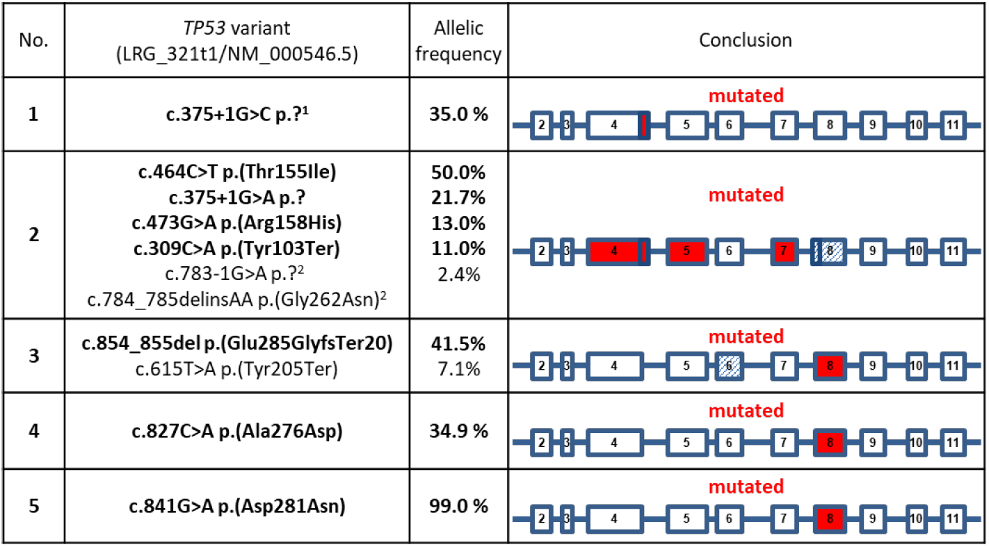

Variants found using QiaSeq LGP

|  |  |  |  |
| --- | --- | --- | --- |
| Sample | Variant | QiaSeq LGP %VAF | ERIC %VAF |
| 1 | c.375+1G>C | 37 | 35 |
| 2 | c.473G>A, p.Arg158His | 11 | 13 |
|  | c.464C>T, p.Thr155Ile | 53 | 50 |
|  | c.309C>A, p.Tyr103Ter | 14 | 11 |
|  | c.375+1G>A | 26 | 21.7 |
| 3 | c.615T>A, p.Tyr205Ter | 9 | 7.1 |
|  | c.854_855delAG, p.Glu285GlyfsTer20 | 42 | 41.5 |
| 4 | c.827C>A, p.Ala276Asp | 33 | 34.9 |
| 5 | c.841G>A, p.Asp281Asn | 99 | 99 |

An r2 correlation of QiaSeq LGP vs ERIC EQA

A Bland-Altman analysis of QiaSeq vs ERIC EQA



|  |  |
| --- | --- |
| Bias | 1.2 |
| SD of bias | 2.208 |
| 95% Limits of Agreement | |
| From | -3.128 |
| To | 5.528 |

## 9.3 Interpretation

Reproducibility for both the QiaSeq MGP and QiaSeq LGP against their respective EQAs is excellent as shown by both r2 and Bland-Altman analysis. The QiaSeq MGP has an r2 correlation of >0.97 and a bias of only 0.14%. Likewise the QiaSeq LGP shown an r2 correlation of >0.99 and a bias of only 1.2%.

In addition, the QiaSeq methodology is able to detect indels of over 100 bp as evidences by the successful detection of FTL3-ITDs of over 100 bp. This performance is superior when compared to the TSCA method.

## 9.4 Outcome / limitations

* The results fulfil the validation requirements for Reproducibility

# SECTION 10.0 : Limit of Detection/Quantification Validation / Verification

(Lower Limit Of Detection determined empirically by determining the lowest quantity of the analyte that can be distinguished from background signal noise (e.g. in a blank) or by extrapolation from a standard curve – state which method you are using)

If this is not required enter Not Applicable and state why (refer also to Table 1) and delete the Work plan & Partial results and conclusions sections

## 10.1 Work plan

|  |  |
| --- | --- |
| **Section aims** | To assess the lower limit of reliable mutation detection (LOD/LOQ).  (read depth data). Demonstrate LOD performance (analytical sensitivity) down to at least 5% VAF and provide operational guidelines for the level of sequence coverage required variant detection down to a LOD of 5% VAF |
| **Samples** | IQC and routine samples. |
| **Methodology** | Control and routine samples have been sequenced multiple times on mid- and high-output runs. Background:  Limit of detection assays often focus on dilution of known variants in the laboratory until a predefined failure of detection occurs. This is part-determined on depth of sequencing and library complexity, which would likely be pre-set or limited in such assays. Increasing depth would inevitably increase the chance of detecting low frequency variants. However, an absolute limit of detection would need to take into account assay specificity as well as analytical sensitivity, where the lowest reliable limit of detection would be when data supporting a true variant rises above that of assay noise. Here we demonstrate such a dilution/LOD assay using practical sequencing levels per sample, which will be achievable and cost effective as standard assay operating conditions.  The amount of depth required to achieve variant detection down to a pre-defined minimum LOD (required analytical sensitivity) can be estimated from statistical formula based around a binomial data distribution, Jennings et al 2017, Petrackova et al 2019). However, this will not take into account potential variables in assay chemistry and analysis. As such, we use actual data in sub-sampling experiments to replace such pure statistical methods in estimating assay depth requirements |

## 10.2 Results

## Technical bioinformatics analysis

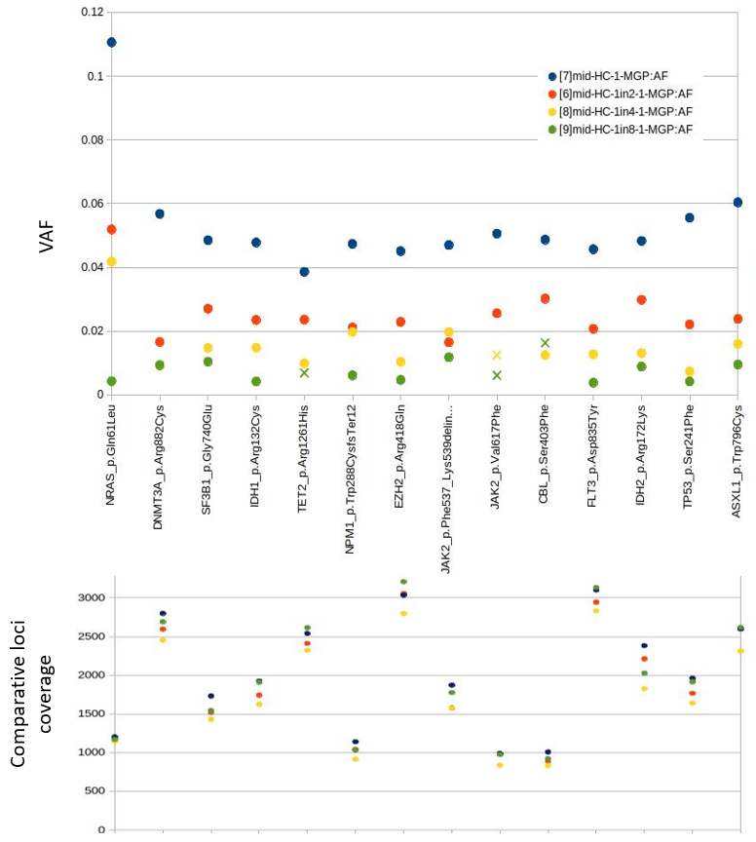

Limit of detection (LOD) by DNA dilution; LOD performance based on routine assay read numbers and related depth of coverage (assay format: 48 multiplexed samples and mid-output NextSeq run). An assessment of the assay analytical sensitivity (or LOD) around the preset assay requirements specified in the validation report acceptance and evaluation criteria. This does not assess assay specificity which is addressed later in this report. This assay was performed on Horizon control DNA 829, containing known mutations associated with hematological malignancy at 5% VAF for the majority, diluted with horizon control 752 DNA, known to be wild type for such selected mutations. 14 mutations were studied here. Dilutions assessed here were 1:2, 1:4 and 1:8. Configurable pipeline thresholds were loosened here so variants with >= 0.003VAF (0.3%) were passed instead of the standard pipeline lower filtering threshold of 0.02 VAF. Variants were not considered unless they were evidenced with 6 supporting reads, as per standard pipeline thresholds. Upper panel: Detected variants were plotted with colored circles based on dilution (see key at top). Where a variant was not detected (including those with less than 6 supporting reads), a cross (X) was plotted at the expected variant VAF based on the dilution factor. The dotted line indicates the threshold at which variants start to drop out in detection (0.0125 [1.25%] VAF). Lower panel: For the same variant positions, depth of coverage is shown for each dilution. Close clustering of coverage levels across dilution series for each variant demonstrates VAF analysis is not driven by any assess coverage bias and shows consistency between experimental repeats.

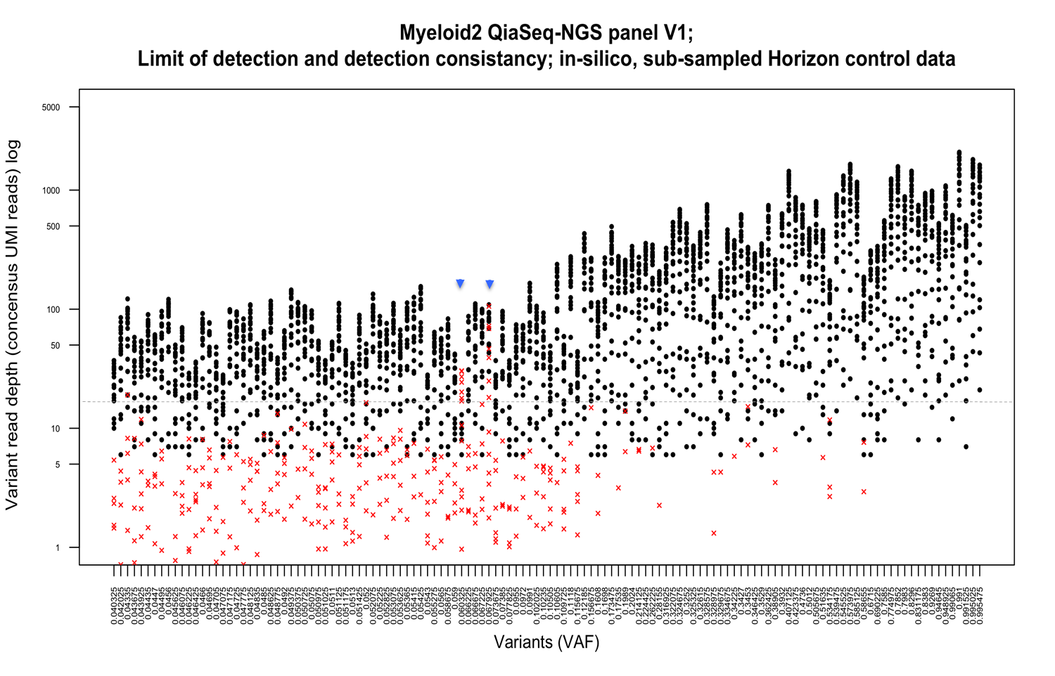

LOD by supporting read depth (see figure legend below)

LOD by supporting read depth. Raw sequence read data (Illumina fastq; Horizon control 829) were sub-sampled in-silico from 2 million reads to 100K reads in 100K steps, and from 100k to 20K in 20K steps. These sampled fastq data were then processed through the Snappy pipeline with VAF and VD thresholds reduced to ≥ 0.005VAF and ≥ 2VD. After merging corresponding variant data (VCF files) for each subsample experiment, the combined data VCF was filtered by intersection with the 134 concordant variants for repeated experiments (≥ 4%VAF avg) on this control DNA (see table 3). Variant supporting reads (variant depth [VD]) for each sub-sampling analysis were plotted for each variant. Where we had detection failure (classified as below standard thresholds of 6 VD and 0.02 VAF ) we inserted the expected variant VD value (calculated using the VAF of the non-sampled data [expected VAF] multiplied by the depth at that position extracted from Snappy coverage.bedgraph data. Subsequently, passed VD values (black dots) and replacement (expected) VD values (red crosses) were plotted against VAF values, ordered from low to high values by expected VAF. The dotted line represents an estimated LOD threshold of 16 supporting reads, after removing the worst performing variant (seen at 4.2 VAF red * ; >99% of the variants used), and two variants removed from the analysis as artifactual calls ( indicated by blue arrows; see appendix, item 2). Below this threshold, increased sampling error is apparent leading to detection failure (<6 VD).

Extrapolating from this data, an estimated 340X sequence coverage would be required to meet 17 (>16) supporting reads on average for a variant having a VAF of 0.05, with a minimum of 6 supporting reads given sub-sampling error in >99% of cases. For a sensitivity level of 0.1 then proportionally less coverage depth would be required.

Discrepant calls from subsampling (LOD by depth) experiment (appendix)

|  |  |  |  |  |  |  |  |  |  |  |
| --- | --- | --- | --- | --- | --- | --- | --- | --- | --- | --- |
| variant | expected VAF | chr | start | bedgraph depth | ref | alt | vardict VD | vardict VAF | vardict depth | sample |
| 1a | 0.060325 | 12 | 111885351 | 498 | ATGGGG | A | 5 | 0.0581 | 86 | hc1-1 |
|  |  |  |  |  |  |  |  |  |  |  |
| 2a | 0.067925 | 17 | 29553477 | 367 | A | CC | 3 | 0.0097 | 309 | hc1-3 |
| 2b | 0.067925 | 17 | 29553477 | 480 | A | CC | 30 | 0.0699 | 429 | hc1-4 |

For the MGP, 2 variants were outliers marked by blue arrows in figure above (representative data shown for each).

For variant number 1, the variant caller was only using a small fraction of the depth indicated at that site (comparing the Bedgraph from clipped.filtered.bam to the ‘Vardict’ variant caller output). Thus variant supporting reads were dropping below 6 VD in many cases, and with this there was an over-estimation of expected VD,( based on bedgraph depth multiplied by expected VAF) compared to variant caller depth . In the example here, bedgraph depth is 498 whereas variant caller depth is 86 (and below threshold VD of 5)

Taking target sequence context into account (AGCAGGATGCAGCGGAACCCCCCCGATTTGCCG), the variant(s) lie within a homopolymeric C run. This is likely to be confounding alignment/realignment. Homopolymers are known to cause such problems. Here a switch from one variant call to another may be happening although in a real case, variable reporting of variant type would likely still see variant effect at same nucleotide from either indel call.

Operational guidelines: Assay read number and coverage requirements

LOD assays indicate that a read coverage across the Myeloid assay ROI region should be ≥340x, to detect allele frequencies down to 5%. Here we assess the number of processed sequence reads required to meet these acceptance criteria for ≥95% of targets (≥400x for ≥ 95% of ROI) and use this along with expected PCR duplication rates to suggest suitable operational parameters (sequencing level per sample/run and number of samples per sequencing run).

Duplication occurs when sequence read numbers surpass library complexity, with consequential re-sequencing (re-sampling) of individual library molecules. This will be affected by input DNA quantity, which was fixed at 40ng here. As the Qiaseq assay and Snappy analysis pipeline uses de-duplicated reads (merged consensus reads based on unique originating gDNA molecule) as its basis for variant calling, then a lower effective library complexity and associated rise in molecular duplication will lead to lower processed read number output and associated DOC. Exampled in figures A-D.

Figure A

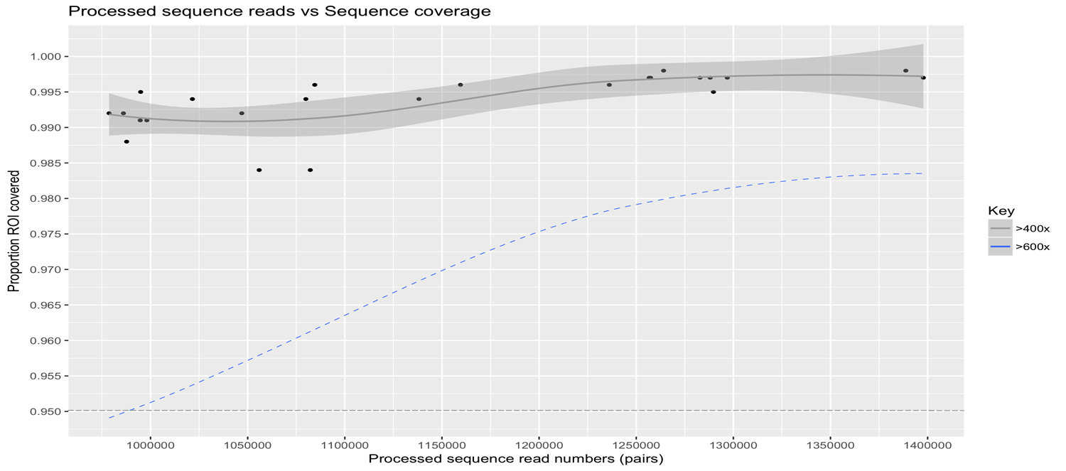

**Figure A**. Coverage *vs* read number, Myeloid Qiaseq assay batch1 (figure A) and batch2 (figure B). Processed sequence read numbers were plotted against sequence coverage (% of ROI covered ≥ 400X or 600X), taking into account LOD by coverage assay analysis performed here. Processed reads represent filtered, de-duplicated (consensus) sequence reads used in variant calling and coverage metric calculations outputted by the Snappy pipeline. Loess ‘best fit’ lines are used to fit data. Horizontal dotted grey lines indicate threshold for 95% ROI coverage. Processed sequence read numbers in batch two were on average higher than batch 1, in line the number of assayed sampled being multiplexed per run (24 vs 48 respectively) providing a higher average raw sequence read number per sample. De-duplication of raw reads to generate consensus reads will reduce the processed read/sample number difference between batches here, although in this case known variable input DNA quality was thought to impact on slightly overall lower coverage performance seen for batch 2 ( evident in at least two lower performing samples indicted by orange box). See figure D and corresponding text for further details on duplication levels and DNA quality variation. In both operational formats corresponding to batch 1 and batch 2, all samples passed assay requirements for depth determined in LOD assays here and associated predetermined acceptance criteria for analytical sensitivity

Figure B

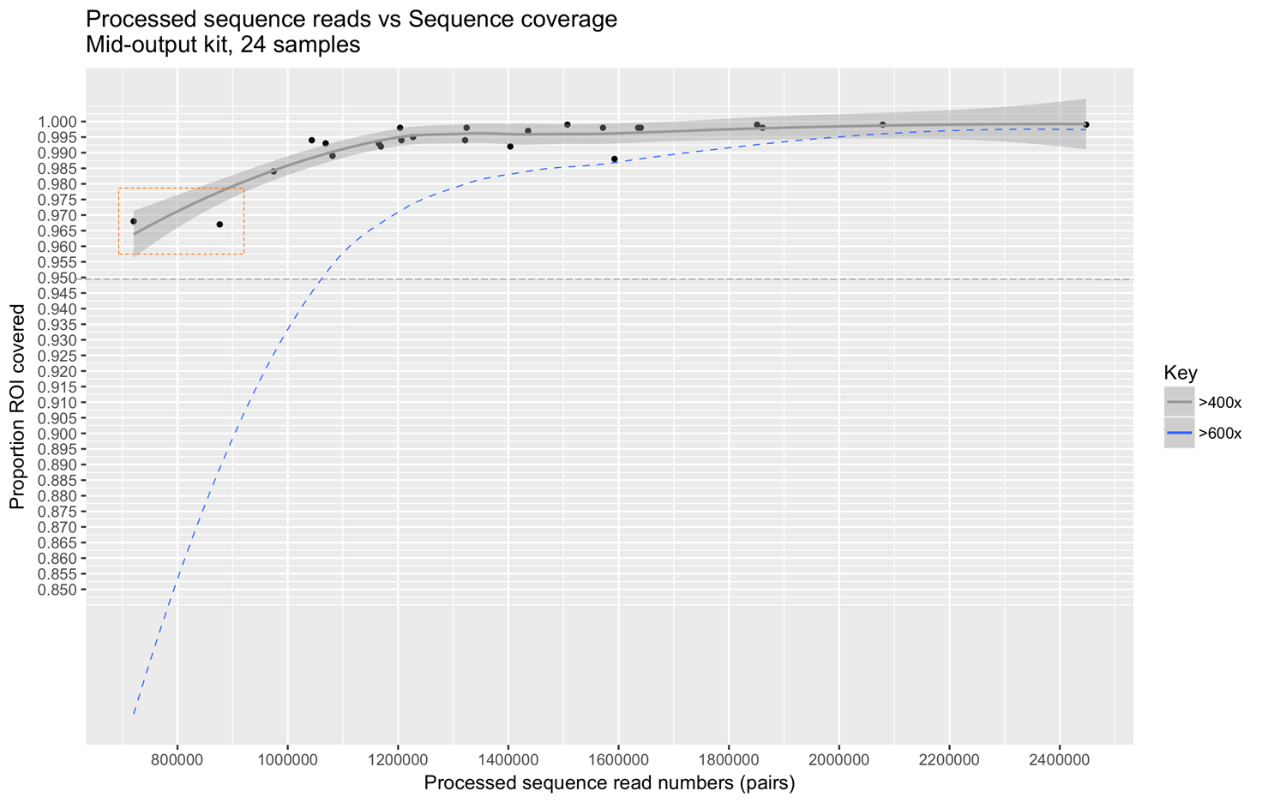

Figure C

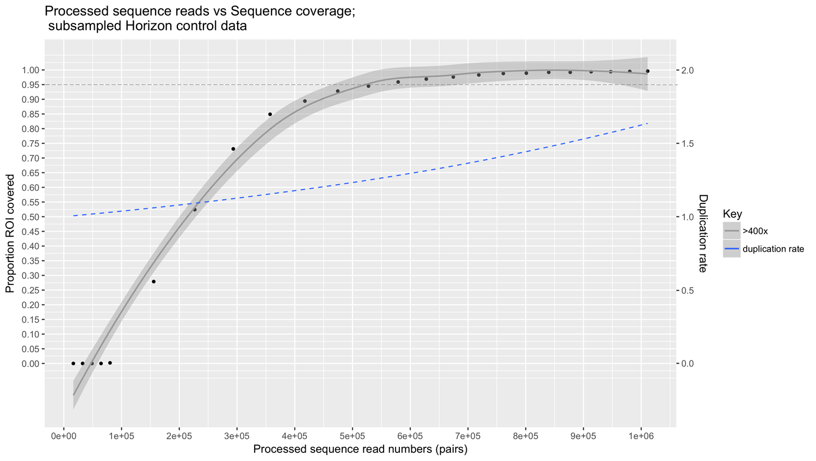

**Figure C**. Plotting the data as for figure A & B, we used sequentially down-sampled fastq for control sample (HC-1) and resulting Snappy outputs to assess depth *vs* reads in a controlled manner. Duplication rate was also plotted against processed read number. To pass the assay validation acceptance criteria of at least 95% of ROI having ≥ 400X sequence coverage, it can be estimated that >525K total processed sequence reads would be needed for each sample assay as a base minimum. To provide contingency for poorer sample-assay performance, seen on occasion here (see figure B and figure D), 800K processed read pairs per sample is recommended here as a suitable lower assay QC pass threshold.

Figure D

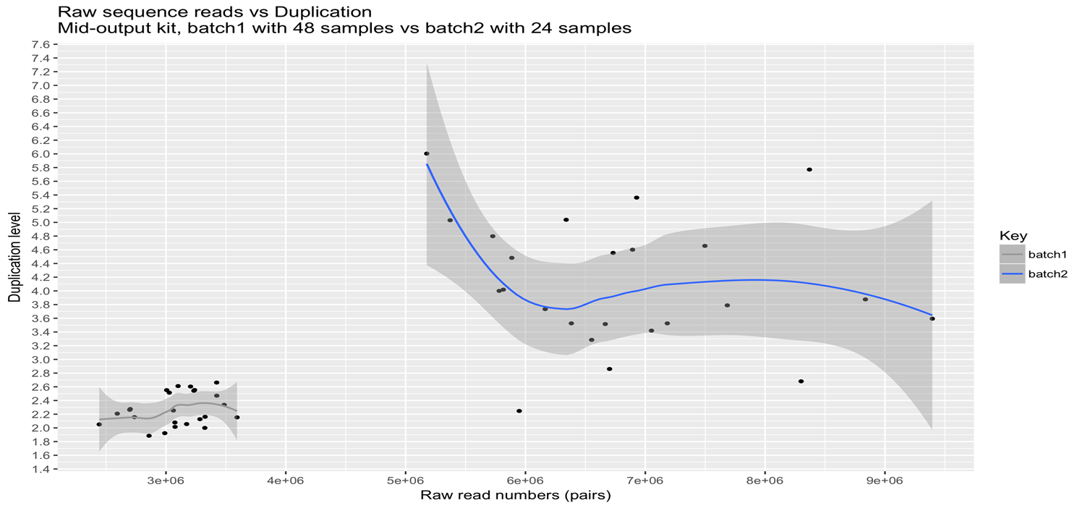

**Figure D**. Duplication rate was plotted against raw read number for assay batch 1 vs batch2. For batch 1, which had relatively less raw reads per sample (see table 2) due to a higher total sample number per run (48) than batch 2 (24), we see a relatively lower raw read/per sample and read duplication level as expected. For this batch, which comprised standard 40ng DNA extracted in batch from sample blood at time of validation, only slight variation in reads/sample was observed, which as expected did not significantly affect duplication levels, which were similar between samples. Batch 2 showed far more variation in both read number and duplication levels, with larger differences in read numbers not correlating with read duplication, as would be expected given no additional assay variables. This was likely to reflect the variable input DNA quality known for this batch of samples (a mixture of routine samples from PB and BM). However, the median processed (de-duplicated) read number for the both the mid-output Nextseq kit for 48 sample assays (1.11 million; batch 1) and the same kit with 24 sample (1.32 million; batch 2) was similar, with read duplication levels absorbing much of the increase in raw sequence read numbers, albeit with a suggestive amplification of this effect through lower DNA quality. Given this, a 24-32 sample assay run paired with the Nextseq mid-output kit, or 48-56 samples run on a high-output kit is the recommended assay running format with build in contingency, minimizing the risk that DNA quality/quantity could potentially lead to a QC fail for processed read number and associated DOC, given higher associated read duplication rates.

**LOW COVERAGE REGIONS**

Given a suggested DOC threshold here of 95% of the ROI requiring ≥ 400X sequence coverage, a maximum of 5% of the regions covered here could have coverage below this threshold. SQVD outputs these low coverage regions (LCRs) which should be reviewed by the clincial scientist reporting on a case by case basis to assess significance and suitability to report assay findings. The clinical scientist may then qualify reported coverage regions by attaching a lower level of analytical sensitivity to these region in line with observed coverage per region. Suggested assay running parameters are aimed at providing DOC contingency (significantly above thresholds for a majority of samples). The table gives breakdown of low coverage events outputted by Snappy with 400X and 340X thresholds for sequence coverage assesses as described on LOD by depth calculations in this report. Low coverage events common to many sample assays here (>5/48) were also considered and can also be factored in to clincial reporting based on functional significance.

|  |  |  |  |  |  |
| --- | --- | --- | --- | --- | --- |
| **Threshold for sequence coverage across ROI** | **Total low coverage events / avg per patient (APP) & APP minus (common events)** | **Size of low coverage regions:**  **mean/median** | **Unique low coverage regions** | **Merged unique LCRs (directly adjacent unique LCRs merged)** | **Low coverage events found in multiple patients (>5):**  **total (total low coverage events)** |
| 400X | Total: 1111  APP: 23 (14) | 28bp/17bp | 540 | 312 | 27  (461) |
| 340X | Total: 344  APP: 7 (3.5) | 55bp/44bp | 129 | 93 | 10  (177) |

## 10.3 Interpretation

**Set assay sequence coverage threshold at ≥400x for ≥ 95% of assay ROI**

Actions – Recommend ≥2 million raw read pairs (NextSeq outputted fastq) per sample and a minimum of 800,000 processed read pairs (based on 40ng recently extracted fresh frozen input gDNA). This is in-line with an operational format of 24-48 samples per Illumina NextSeq mid-output run (2x150bp). If DNA quality/quantity is an unknown , running lower sample numbers should be considered to overcome lower assay performance and associated higher duplication rates. DNA input amounts may also need to be adjusted accordingly (currently in validation for 60ng). 24-36 sample/NextSeq mid-output should be the running format until working data indicates otherwise.

## Operational guidelines and QC thresholds

|  |  |
| --- | --- |
| $1B. Input requirements | Contingency |
| 40ng input DNA | For cases which cannot achieve 40ng, monitor other QC measures closely. Consider increasing amount of sequencing to increase coverage depth. Rpt assay if necessary. |

|  |  |
| --- | --- |
| $1C. Sequencing level | Contingency |
| Run 24-48 samples per run – Nextseq mid-output 2x150bp (≥2.5 million raw sequence read pairs per sample) | NA |
| Recommend ≥800K processed read pairs per sample  (LOD ≥ 0.05 VAF and >95% ROI >400X DOC) | Below this level, consult QC for coverage/low coverage regions, and caveats therein. |

|  |  |
| --- | --- |
| QC soft thresholds | Action and contingency |
| ≥95% of ROI having ≥400X sequence coverage  (for LOD ≥ 0.05VAF) | Recommend repeat assay. Otherwise at the discretion of the clincial team and considering: the extent of sub-threshold coverage; individual low coverage regions; failed primer level, base quality and other indicators of lower quality data in QC reports; required assay LOD given clinical context. |
| ≤ 2% failed target primers | As above. Surrogate and highly-linked to coverage. As primer targets overlap, one failed primer my compensate for another. |
| ≥ 90% of bases passing Q30 base quality | Recommend repeated assay. Otherwise at the discretion of the clinical team and considering other QC measures and required assay LOD and specificity closely. Sense check variant output for obvious artifactual background. |
| Molecular duplication rate <5-8 | Assess against sequence coverage measures. High levels of duplication linked to DNA quality and quantity, and will likely cause sequence coverage to drop below acceptable levels at suggested sequencing levels. |
| Monitor low coverage regions  at <400X (considering ≤ 340X as minimum for LOD of 0.05VAF) | Monitor and consider extent against clinical context and required sensitivity/LOD on case by case basis. |

## 10.4 Outcome / limitations

* The stated requirements of the validation have been fulfilled.
* The ideal minimum coverage is 400x, however variants may be called if the coverage is less than this at the discretion of the reporting Clinical Scientist.

# SECTION 11.0 : Measurement Uncertainty Validation / Verification

Refer to ISO15189 standards dealing with Measurement Uncertainty and to guidance on determination of Measurement Uncertainty. State which methods will be used (“Top Down” or “Bottom Up”) and reference which raw data has been used.

MU must still be estimated or described for “qualitative” tests (Test types B to E in Table 1) by measuring or describing variability in the quantitative signal.

## 11.1 Work plan

|  |  |
| --- | --- |
| **Section aims** | The overall Measurement of Uncertainty (Type A) will be calculated by combining the uncertainties from repeatability and intermediate precision measurements. |
| **Samples** | The Horizon control will be used to estimate measurement uncertainty. Data from repeatability experiments will be used. |
| **Methodology** | Uncertainty Measurements will be calculated separately for mutation burdens of <20% and mutation burdens >20%.  Calculating the estimated standard deviation for a series of *n* measurements can be expressed mathematically as $$s=\sqrt{\frac{\sum_{i=1}^{n}{{\left(x_{i}-\overline{x}\right)}^{2}}}{\left(n-1\right)}}$$ From these, the estimated standard uncertainty, *u*, of the mean is calculated from: $$u=\frac{s}{\sqrt{n}}$$ where *n* was the number of measurements in the set.  Independent standard uncertainties are combined using: $$combined uncertainty u_{c}=\sqrt{a^{2}+b^{2}+…ⅇtc}$$ The combined uncertainties can be stated at a confidence level of 95%, which is done by multiplying $u_{c}$ by a coverage factor, *k=2*, to give an expanded uncertainty *U*. $${U=ku}_{c}$$ |

## 11.2 Results

Data from repeatability experiments using the Horizon myeloid control. Uncertainty results are shown for each variant (last row), repeated in 8 samples, as well as other parameters such as 95% CL and CoV. The variants are grouped as <20% or >20% VAFs.



For variants below 20%

$combined uncertainty u_{c}=\sqrt{{u1}^{2}+{u2}^{2}…+.}$ = 1.21%

For variants above 20%

$combined uncertainty u_{c}=\sqrt{{u1}^{2}+{u2}^{2}…+.}$ = 1.43%

## 11.3: Interpretation

For variants below 20% *U*= 2.43% (TYPE A)

For variants above 20% *U*= 2.85% (TYPE A)

The reported uncertainties are based on a standard uncertainty multiplied by a

coverage factor *k* = 2, providing a level of confidence of approximately 95%.

This Type A uncertainty calculation is described in UKAS Publication M 3003 and NPL Measurement Good Practice Guide No. 11 (Issue 2).

## 11.4: Outcome / limitations

* Calculation of Measurement Uncertainty fulfils the validation requirements.

# SECTION 12. Validation / Verification Final Conclusions

## Deviations Observed:

1. No deviations were observed

## Changes to the Validation Plan or other documents that may be necessary:

1. No changes are required.

## Issues / Commentary

1. None noted.

## Revalidation Criteria\Conditions based on validation findings:

1. Assay monitoring (including measurement of uncertainty) will take place on an ongoing basis using the IQC and NEQAS samples.

|  |  |
| --- | --- |
| **Overall Conclusion** | **The requirements listed in Section 1.2.1 have been fulfilled.** |

|  |  |  |
| --- | --- | --- |
| **Critical Function** | **Acceptance Criteria** | **Pass/Fail** |
| Technical assessment of performance and robustness using appropriate quality metrics | The quality metrics generated for a series of samples should show good coverage, with consistent primer performance between runs and samples. As part of this assessment, the vertical coverage (sequencing depth) and the horizontal coverage of the regions of interest (ROI) will be examined. | Pass |
| Detection specificity and sensitivity | Where qualitative data is available from another ISO15189-accredited assay, on the same samples, or a standard from a commercial source, we expect ≥95 % sensitivity and specificity. | Pass |
| Trueness | Where quantitative data is available from a standard, such as a commercial source, a high level of trueness must be evident, as given by either r2 correlation (≥0.9) or Bland-Altman analysis. | Pass |
| Linearity | Where quantitative data is available, a high level of linearity must be evident, as given by r2 correlation (≥0.9). Aspects of this may be used, if possible, to define limit of detection (LOD) and/or limit of quantitation (LOQ). | Pass |
| Repeatability/ intra-assay precision | If available, intra-assay repeat samples should be analysed for both presence/absence calls as well as quantitative correlation. Measurement Uncertainty calculations should be performed using this data. | Pass |
| Intermediate/ inter-assay precision | If available, inter-assay repeat samples should be analysed for both presence/absence calls as well as quantitative correlation. Measurement Uncertainty calculations should be performed using this data. | Pass |
| Reproducibility | A cross-comparison between different methodologies and NEQAS or other EQA samples, should show a high level of reproducibility. This data may be inferred using Trueness and Linearity data where appropriate. | Pass |
| LOD/LOQ | Our requirement is to detect a clone size of ≥5%, therefore the read depth required to achieve this will be determined: demonstrate LOD performance (analytical sensitivity) down to at least 5% VAF and provide operational guidelines for the level of sequence coverage required for variant detection down to this level. | Pass |
| Measurement Uncertainty | This will be calculated based the precision data. | Pass |
| NextSeq 550 Run Performance | Sequencing metrics obtained from the NextSeq instrument should be within the performance specifications of the manufacturer. This data is presented in the NextSeq Instrument Validation document, but will be summarised here. | Pass |

# TEST VALIDATION/VERIFICATION FINAL APPROVAL

|  |  |  |  |
| --- | --- | --- | --- |
| **Authorisation** | Name | Signature | Date |
| Investigating scientist | Alex Smith |  |  |
| Investigating scientist | Steve Best |  |  |
| Senior Scientist (Authorisation) | Nicholas Lea |  |  |
| Quality Manager | Tanya Scott |  |  |

# APPROVAL FOR TEST INTRODUCTION

[Depends on passing of **all** critical steps].

|  |  |  |
| --- | --- | --- |
| **Release** |  | *Validation/verification protocol & post validation checklist completed, unconditional release for clinical diagnostic/monitoring use\** |
| **Conditional** **Release** ** |  | *Additional validation/verification or post validation actions needed but release permitted providing certain conditions are met\*\** |
| **Failure** |  | *Validation/verification failed, therefore complete restart of validation/verification required* OR test should not be used for clinical diagnosis/monitoring \** |

*\* Delete as appropriate*

*\*\* Describe conditions / further testing required:*

1. All requirements have been fulfilled; therefore no further testing is required, however, ongoing validation will be appended to this document as and when required.

**Release Authorised by**

|  |  |  |  |
| --- | --- | --- | --- |
| **Authorisation** | Name | Signature | Date |
| Laboratory Manager | Nicholas Lea |  |  |
| Quality Manager | Tanya Scott |  |  |